Measures of Correlation

Pete Smith, PRM, FSA, MAAA

Correlation has many uses and definitions. As Carol Alexander, 2001 observes, correlation may only be meaningfully computed for stationary processes. Covariance stationarity for a time series, y_{t}, is defined as:

- Constant, finite mean
- Constant, finite variance
- Covariance(y_{t}, y_{t-s}) depends only on the lag s

For financial data, this implies that correlation is only meaningful for variates such as rates of return or normally transformed variates, z, such that:

z = (x - μ)/σ

Where x is non-stationary and μ is the mean of x and σ the standard deviation. For non-stationary variates like prices, correlation is not usually meaningful.

A more coherent measure of relatedness is cointegration. Cointegration uses a two-step process:

- Long-term equilibrium relationships are established
- A dynamic correlation of returns is estimated

Cointegration will not be discussed in these ERM sessions, however, it is very important in developing dynamic hedges that seek to keep stationary tracking error within preset bounds. Hedging using correlation measures typically is not able to achieve such control.
However, instantaneous and terminal measures of correlation are used in various applications such as developing stochastic interest rate generators.

Definitions of Correlation

Pearson’s correlation formula
Linear relationships between variables can be quantified using the Pearson Product-Moment Correlation Coefficient, or

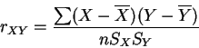

The value of this statistic is always between -1 and 1, and if and are unrelated it will equal zero.
(source: http://maigret.psy.ohio-state.edu/~trish/Teaching/Intro_Stats/Lecture_Notes/chapter5/node5.html)
Spearman's Correlation Method
A nonparametric (distribution-free) rank statistic proposed by Spearman in 1904 as a measure of the strength of the associations between two variables (Lehmann and D'Abrera 1998). The Spearman rank correlation coefficient can be used to give an R-estimate, and is a measure of monotone association that is used when the distribution of the data make Pearson's correlation coefficient undesirable or misleading.
The Spearman rank correlation coefficient is defined by
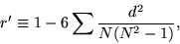 | (1)

where d is the difference in statistical rank of corresponding variables, and is an approximation to the exact correlation coefficient
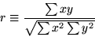 | (2)

computed from the original data. Because it uses ranks, the Spearman rank correlation coefficient is much easier to compute.
The variance, kurtosis, and higher-order moments are
 |  | 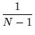 | (3)
 |  | 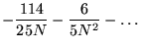 | (4)
 |  |  | (5)
Student was the first to obtain the variance.
(source: http://mathworld.wolfram.com/SpearmanRankCorrelationCoefficient.html)
The Simple Formula for r_{s}, for Rankings without Ties
Here is the same table you saw above, except now we also take the difference between each pair of ranks (D=X—Y), and then the square of each difference. All that is required for the calculation of the Spearman coefficient are the values of N and-D², according to the formula
wine | X | Y | D | D²
a  b  c  d  e  f  g  h | 1  2  3  4  5  6  7  8 | 2  1  5  3  4  7  8  6 | —1  1  —2  1  1  —1  —1  2 | 1  1  4  1  1  1  1  4
N = 8 -D² = 14
 | r_{s} | = | 1 — | 6D²  N(N²—1)

(source: http://faculty.vassar.edu/lowry/ch3b.html)
There is no generally accepted method for computing the standard error for small samples.

Kendall's Tau Coefficient
Spearman’s r treats ranks as scores and computes the correlation between two sets of ranks. Kendall’s tau is based on the number of inversions in rankings.
Although there is evidence that Kendall's Tau holds up better than Pearson's r to extreme nonnormality in the data, that seems to be true only at quite extreme levels.
Let inv := number of inversions, i.e. reversals of pair-wise rank orders between n pairs. Equal rankings need an adjustment.
τ = 1 – 2* inv/(number of pairs of objects)
= 1 - 2 * inv/ (n*(n-1)/2) = 1 – 4* inv/(n*(n-1))
(source: http://www.psych.yorku.ca/dand/tsp/general/corrstats.pdf)

*********************************************************************

The preceding correlation definitions weight all observations equally. Hence, clustering of data associated with periods of high and low volatility is not reflected. High volatility periods often display higher levels correlation risk. For example, when the Russian Rouble became distressed and highly volatile in 1998, the third world debt market experienced contagion.

The Spearman and Kendall Tau measures are more appropriate for non-normal distributions.

The above definitions of correlation are absolute and will only accidentally replicate implied market correlations. Bayesian or conditional definitions of correlation are more appropriate for time series and stochastic models as relationships such as volatility smiles may be captured.

*********************************************************************

Instantaneous Correlation

ρ_{ij}(u) := instantaneous correlation between variables with indices i,j a moment u.

(see Rebonato, Modern Pricing of Interest-Rate Derivatives, 2002)

Instantaneous correlation in a hedging model may be based on forecasts of future correlation. An empirical function relating the value of a position to the associated correlation may be derived. The empirical function is then used to vary instantaneous correlation as the underlying value of the position changes. Instantaneous correlations my then be used to compute the associated terminal correlation.

Terminal Correlation

term_ρ_{ij}(T) = [∫₀^{T}σ_{I}(u)σ_{j}(u)ρ_{ij}(u)du] / √(v_{i}v_{j})

where: v_{i} = ∫₀^{T}σi(u)²du

Terminal correlation is usually the more germane measure of correlation for pricing and hedging.

(see Rebonato, Modern Pricing of Interest-Rate Derivatives, 2002)

Implied Correlation

The implied volatility on the cross rate on a foreign exchange process may be expressed as:

σ²_{x-y} = σ²_{x} + σ²_{y} -2σ_{x}σ_{y}ρ

which may be solved options are available on the f/x rates and cross, i.e.:

ρ = (σ²_{x} + σ²_{y} - σ²_{x-y})/(2σ_{x}σ_{y})

In the above example, ρ is the implied correlation.

(see Alexander, Market Models, 2001)

Confidence Intervals for Correlation Point Estimates: Fisher-z transformation

Let ρ be a point estimate of the correlation r, define the transformation z:

z = ½ ln[(1+r)/(1-r)]

When the sample is large (25 or more is a useful rule of thumb), the distribution z is approximately normal with an approximate mean and variance:

E(z) = ½ ln[(1+ρ)/(1-ρ)] and σ(z) = 1/(√(n-3))

The standardized statistic, (z – E(z))/σ(z)), is approximately a standard normal variable. Therefore, approximate 1 - α confidence limits for z are: E(z) ± (1 - α/2)σ(z). The 1 - α limits for ρare then obtained by transforming the limits on z by means of:

ρ = (exp(2z) – 1)/(exp(2z) + 1)

Relationship Between Correlation and Volatility

In Volatility and Correlation in Option Pricing,1999, in the context of two imperfectly correlated variables, Ricardo Rebonato states,

“Under these assumptions we can now run two simulations, one with a constant …identical volatility for both variables and with imperfect correlation, and the other with different instantaneous imperfect correlation, and the other with instantaneous volatilities …but perfect correlation. One can then evaluate correlation, calculated along the path, between the changes in the log of the two variables in the two cases. …As is apparent from the two figures, the same sample correlation can be obtained despite the fact that the two de-correlation-generating mechanisms are very different.

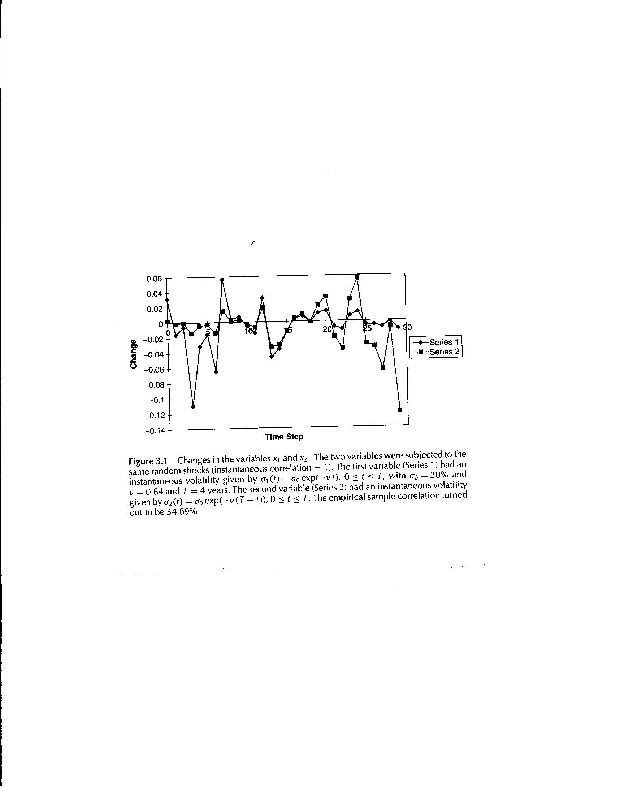

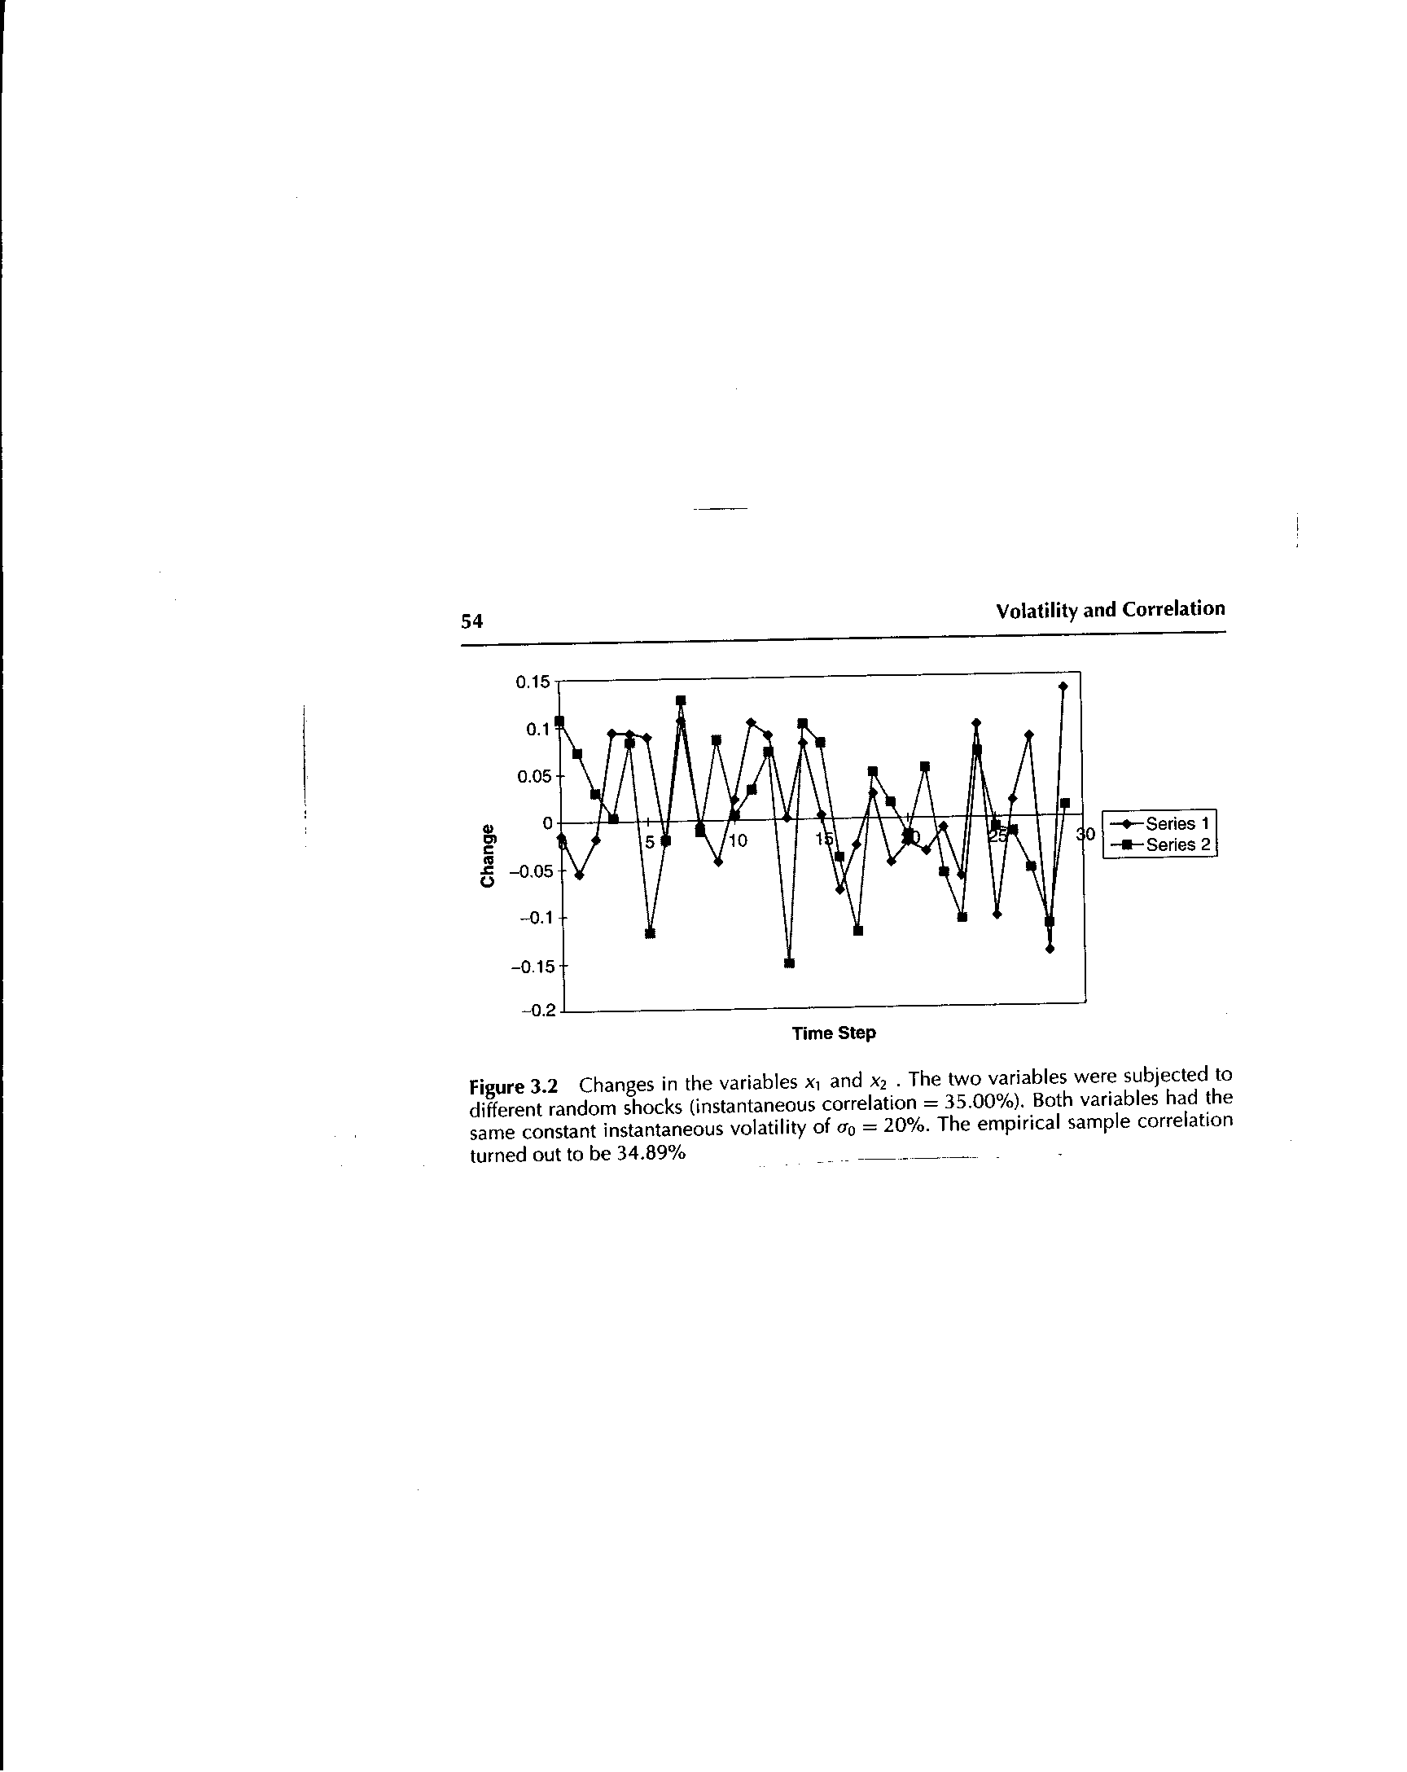

In Market Models, 2001, Carol Alexander observes,

“Unlike prices, volatility and correlation are not directly observable in the market.
They can only be estimated in the context of a model. It is important to understand that implied and statistical volatility models provide estimates or forecasts of the same thing—that is, the volatility parameter in some assumed underlying price process.

The following empirically derived graphs show instantaneous correlations as a function of option value. These relationships allow forecast and simulation processes to vary correlation conditional on the level of the option price.

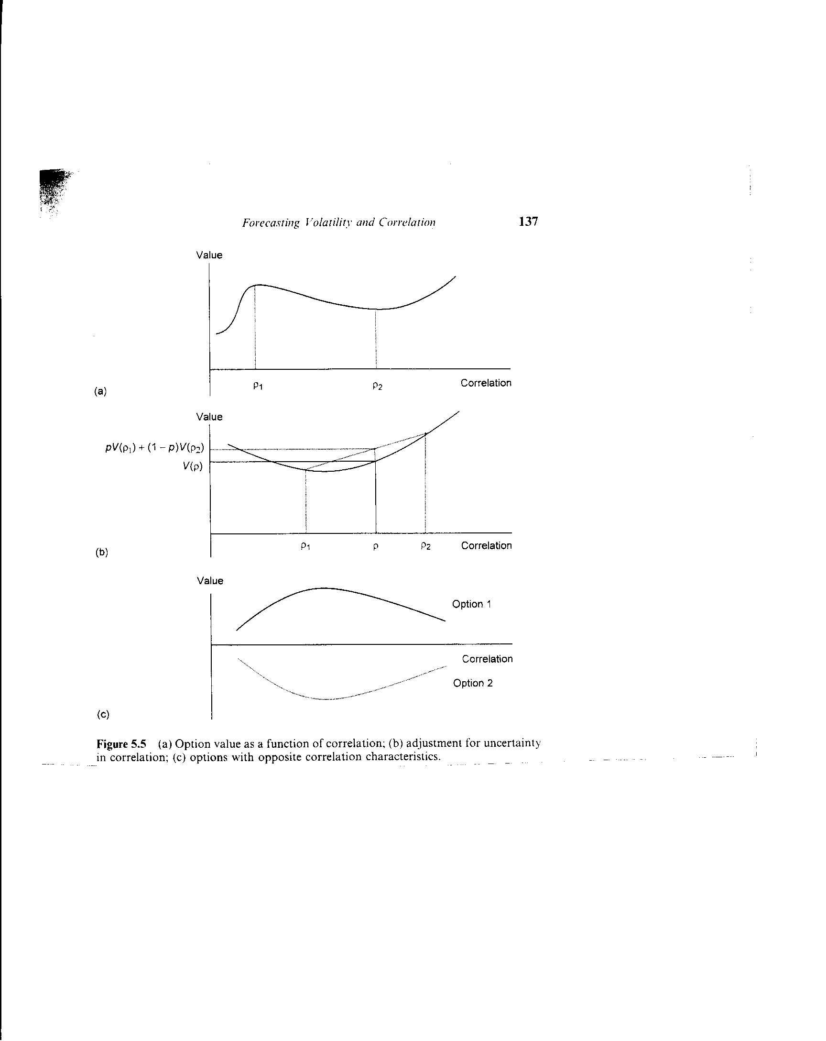

Correlation Methods

GARCH Models: Generalized Autoregressive Conditional Heteroscedastic

(Reference for GARCH Models: Carol Alexander, Market Models, 2001)

Heteroscedastic models have varying volatility.
GARCH models are Conditional time series models where the current variable volatility depends on prior values.
AutoRegressive models have the mean reversion property.
The Generalized form of the model results in instances that constitute a family of models with varying parameters.

GARCH models are important in finance because they enable modeling of volatility clustering. Volatility clustering occurs because periods of high volatility in trading financial assets are interspersed with periods of low volatility. GARCH models enable clustering to be captured without implementing full chaos models. Full chaos finance models often develop incomplete markets, i.e. replicating strategies will not exist.

ARCH(p)

The ARCH(p) process captures the conditional heteroscedacticity as a weighted average of past squared unexpected returns:

σ²_{t} = α₀ + α₁ε²_{t-1} + … + α_{p}ε²_{t-p}

α₀ > 0, α₁, …, α_{p} ≥ 0 ε_{t}⎟ I_{t} ∼ N(0, σ²_{t})

ARCH models are rarely used in finance as simple GARCH models perform so much better.

GARCH(p,q): Symmetric GARCH

σ²_{t} = α₀ + α₁ε²_{t-1} + … + α_{p}ε²_{t-p} + β₁σ_{t-1} + … + β_{q}σ²_{t-q}
α₀ > 0, α₁, … , α_{p},β_{1,} …, β_{q}≥ 0

It is rarely necessary to use more than a GARCH(1,1) model for financial applications.

GARCH(1,1)

σ²_{t} = ω + αε²_{t-1} + βσ²_{t-1}

ω > 0, α, β ≥ 0

The GARCH(1,1) model is equivalent to an infinite ARCH model with exponentially declining weights.

I-GARCH

α + β < 1 if the returns process is to be stationary. Which is necessary for mean reverting processes.

If α + β = 1, the return process is a random walk, and the GARCH(1,1) process may be expressed as:

σ²_{t} = ω + (1 - λ)ε²_{t-1} + λσ²_{t-1}

λ = β , 1 ≥ λ ≥ 0

Such models are called integrated GARCH or I-GARCH models. I-GARCH models are often appropriate in foreign exchange markets.

When ω = 0, the I-GARCH model becomes an EWMA (exponentially weighted moving average) model.

A-GARCH: Asymmetric GARCH

Equity markets are typically more volatile in falling markets than rising markets.
A-GARCH models were designed to fit such markets.

E-GARCH: Exponential GARCH

The first A-GARCH model was the E-GARCH or Exponential GARCH model, of the following form:

ln σ²_{t} = ω+ g(z_{t-1}) + β lnσ²_{t-1}

where g(*) is an asymmetric response function defined by:

g(z_{t}) = λz_{t} + ϕ( |z_{t}| - √(2π))

z_{t} is the standard normal unexpected return ε_{t}/σ_{t}

N-GARCH: non-linear GARCH

r_{t} = r - .5σ²_{t} + σ_{t}ξ_{t}

σ²_{t} = ω + ασ²_{t-1}(ξ_{t-1} - θ - λ)² + βσ_{t-1}

ξ_{t} = ε_{t} + λ
N-GARCH models are typically not risk-neutral, although local risk-neutrality may exist. Models that are not risk-neutral are incomplete and generally do not have replicating portfolios everywhere available. Hence, hedging may not be possible. Typically
N-GARCH models are more complex than the preceding GARCH models in this presentation. For these reasons N-GARCH models are not currently used as extensively in finance as other GARCH models.

High-Frequency GARCH Models

Model frequency is a function of the time interval associated with return observations. So hourly observation is more frequent than daily and daily is more frequent than weekly, and so on.

Most GARCH models in practice assume that unexpected portion of the actual return is conditionally normally distributed. Non-normal models are characterized by fat tailed distributions for the unexpected portion of the return. t-GARCH models develop the unexpected portion of the return according to a student-t distribution. Non-normal models may be developed by modifying the likelihood function used to estimate the model parameters.

High frequency models, especially intra-day models, are much more likely to be more volatile and fat-tailed than lower frequency models.

Relationship of Correlation and VaR

Covariance VaR changes linearly as the underlying model or factor variable instantaneous correlations change. Likewise non-linear VaR will change non-linearly as the instantaneous correlations change. Dynamic hedging costs should properly reflect the VaR cost of capital.

Bibliography and Future Readings

Various readings have been referenced through the progress of this presentation. As the presentation is intended to provide a summary of correlation concepts in preparation for the subsequent sessions, the concepts herein are not original to the presenter. A guide to original work is provided so that attendees may develop a deeper understanding of the subject.

Carol Alexander, Market Models, Wiley, 2001

If you read one book on these subjects, Ms. Alexander’s Market Models is highly recommended. The book contains lucid and intuitive summaries of highly complex ideas. Market Models is a pleasure to read.

Ricardo Rebonato, Volatility and Correlation in Option Pricing, Wiley, 1999

Volatility and Correlation discusses advanced topics beyond Market Models. Like all of Rebonato’s books, it is highly lucid and empirically focused.

Other Recommended Readings

Engle, 2003 Risk USA presentation

Mantegna and Stanley, An Introduction to Econophysics : Correlation and Complexity in Finance, Cambridge, 2000

Bouchaud and Potters, Theory of Financial Risks, Cambridge , 2000

Interesting Applied Models

R. Rebonato, Modern Pricing of Interest-Rate Derivatives: The Libor Model and Beyond, Princeton University Press, 2002

J. Rosenberg, Non-Parametric Pricing of Contingent Claims, Journal of Derivatives, Spring 2003

