Make Your Actuarial Spreadsheets Fly
Designing and Programming Spreadsheets for Risk Measurement

By
William C. Scheel
DFA Technologies, LLC

Contents
Contents 1
Introduction 1
VBA Programming Required 2
System Requirements 2
References 2
Road Map for the DFATech Workbooks 3
Generate.xls: Claims Simulation and Bootstrap 3
Figure 1 Menu for Generate.xls 5
SimpleConvolution.xls: Reinsurance Slice’n’Dice 5
Figure 2 Menu for SimpleConvolution.xls 6
Burville.xls: Exercises in Range Specification, Use of Excel’s VLOOKUP 6
Figure 3 Menu for Burville.xls 7
MultiPlatform.xls: Using MSMQ for Multiple Computer, Excel Simulations 7
Figure 4 Menu for MultiPlatform.xls 9
Setting Up MSMQ 9
Setting Up the Registry Private Queue 11

Introduction
I have for a long time felt that spreadsheet-centric solutions to simulation problems have been under-utilized. Although there are excellent, turn-key systems available from vendors, they are all costly. I doubt that there is any problem these systems purport to handle that cannot be done expeditiously and much less expensively using Microsoft Excel. At the 2002 Risk and Capital Management Seminar I challenged some of criticisms of spreadsheet-centric solutions.

These notes accompany Excel workbooks that I used in that presentation. I apologize to readers because these workbooks are not organized into a tutorial. And, the notes here certainly do not constitute documentation; my workbooks are bereft of help.

But, the “tricks” contained in the workbooks are, in my judgment worthy. A study of them will undoubtedly cause one to reconsider the merits of spreadsheet-centric solutions. The various tricks illustrated in these examples reflect many years of model development. Someday, I’ll do a better job of the pedagogy in these workbooks. With my apologies, for now, you’re largely on your own slugging through them. But, if you do get that far, you will see high performance loss simulation, event-driven reinsurance pricing, multi-computer Excel simulation methods and many examples of object handling using VBA programming. This is not smoke and mirrors relying on exogenous C++ or fortran DLLs…it is all right out of the (Excel) box.

VBA Programming Required
If you want to build something, your productivity is improved with the proper tools. This is true of spreadsheet-centric model building. If you purport to be a spreadsheet-centric model builder, you need VBA programming tools because you’ll sing a better song. Besides, actuarial model builders should find a VBA learning experience to be easy, fun and rewarding. If this programming element is not within the calculus of your model building, you may want to close the book. But, I still recommend trying SimpleConvolutions.xls. Here, you will see some pretty fast reinsurance stuff. If you seek more out your data check out the bootstrapping methods illustrated in Generate.xls.

System Requirements
The workbooks were designed to use modeless dialogs; this means you need Excel version 2000 or 2002. Modeless dialogs enable you to move back and forth between worksheets and dialogs without closing the dialogs. With some modest code work on the Excel forms to make them modal, the workbooks likely will work with earlier versions of Excel.

References
The examples use various system class libraries. All are supplied automatically either by Excel or the Windows operating system. However, the locations may not get resolved properly. The result is that you will get compile errors when the system macros attempt to run. They are setup within the VBA Editor (alt-F11). Press Tools.References…, and a dialog similar to the one below will appear. You must have the items checked in the screen show below.

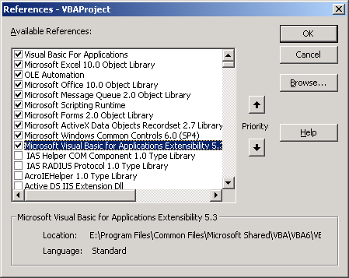

Road Map for the DFATech Workbooks
The companion PowerPoint presentation may help identifying what tricks each workbook explores. The following sections attempt to expand this a bit and give you a better sense of the menus and operation. However, nothing here (or there, except for code comments) will attempt to explain the code.

There is not particular order to the workbooks…perhaps the one shown in the PowerPoint presentation represents a more nature progression of “easy” to “difficult.” However, the workbooks do not necessarily build on one another.

Each workbook has a DFATech menu item that contain buttons for dialogs. You should begin there. In addition, there is an “IDE Code Finder” option that will jump you into various sections of the code which I think are particularly important. Some familiarity with the VBA code editor is essential. Lacking that experience, the place for you to begin is with one of the VBA books listed on the References slide in the PowerPoint presentation. But, you still can play around with the simulation methods that are illustrated in the workbooks.

Generate.xls: Claims Simulation and Bootstrap
This workbook illustrates the generation of a worksheet of claims that can be used for bootstrapping. It illustrates how fast Excel’s VLOOKUP function can be for any intervalized distribution. However, the function’s range is calculated using code; that is what helps performance. It is one of many illustrations throughout the workbooks where assistance with VBA coding can produce superior performance over alternative solutions that are based solely on cell functions.

Generate.xls shows preparation of a bootstrap sample obtained by dereferencing a block of cells. I consider the “tricks” used to layout the bootstrapping process in this workbook to be novel and instructive. The bootstrap sample range contains cells whose contents randomly select from another worksheet’s claims. This bootstrap sample range uses Excel’s INDEX function. The creation of an entire bootstrap sample is done with a simple trick using dynamic references constructed with this Excel function. Repeated calculation of this range generates a unique bootstrap sample that then can be used to calculate a sampling distribution for a statistic of interest. Very cool.

You need to run the first menu item before the bootstrap. The creation of the bootstrap is done in two steps. “Prepare bootstrap worksheet” menu item takes a block of the data you select and creates a worksheet with the special cell references. Be sure to look at the “Bootstrap” worksheet and the range beginning in cell “a1” after you do this operation.

Then, you can use this range to generate the bootstrap samples that are used to derive statistics of interest (press “Calculate Bootstrap Samples”). Each cell in the bootstrap sample range has a formula similar to:

=INDEX(Data!$C$8:$M$32,INT(RAND()*25)+1,INT(RAND()*11)+1)

When the range is recalculated, the RAND sets the index offsets to new locations within the bootstrap data block (Data!$C$8:$M$32 in the above formula).

Figure 1 Menu for Generate.xls
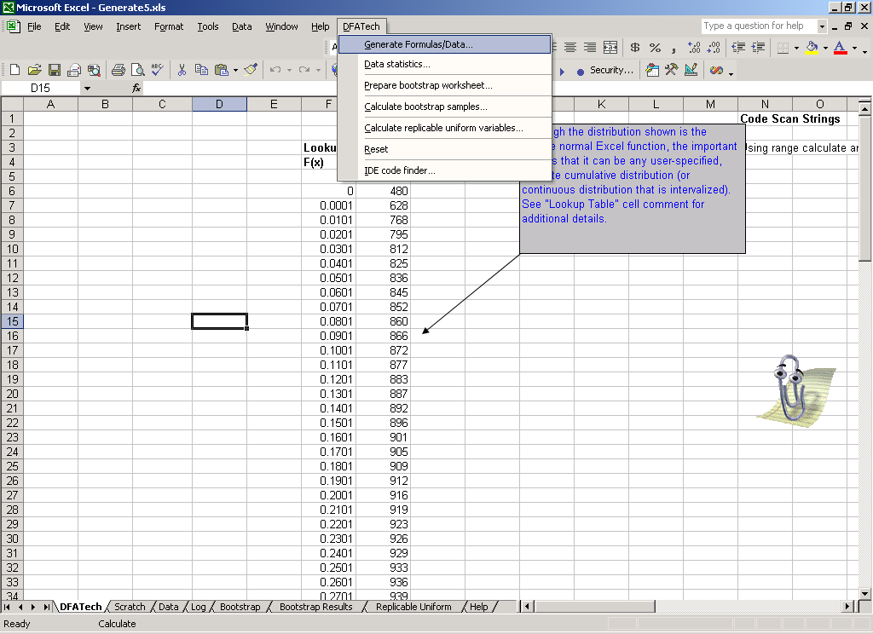

SimpleConvolution.xls: Reinsurance Slice’n’Dice
This workbook creates frequencies and severities in worksheets. These worksheets could contain actual claims information. A table of layers with participation is created (there is no user interface for this…see TransferLimits range on the DFATech sheet). When the aggregate loss distribution menu option is selected, the indicated trials are run; each trial produces a result for the aggregate loss distribution of the layer/share. A frequency is selected from Frequencies worksheet, and then that many severities are gathered from the Severities worksheet and censored. The example uses an aggregate excess for censoring, but any event-driven censoring could be programmed.

This SimpleConvolution workbook serves double-duty in a multiple computer application, MultiplePlatform.xls. The aggregate loss information produced on the various participating computers is pooled; however, each computer really is running an instance of SimpleConvolution.xls.

Notice the settings in for Average Frequency. The normal distribution approximation to the Poisson for large average frequency is used; the Events count determines how may samples are drawn from this distribution and persisted in the Frequencies worksheet. Similarly, severities are drawn using the lognormal distribution specified in Severity worksheet. These severity events are persisted in the Severities worksheet.

Were the censoring to have been done using cell formulas, the performance would be much worse.

Figure 2 Menu for SimpleConvolution.xls
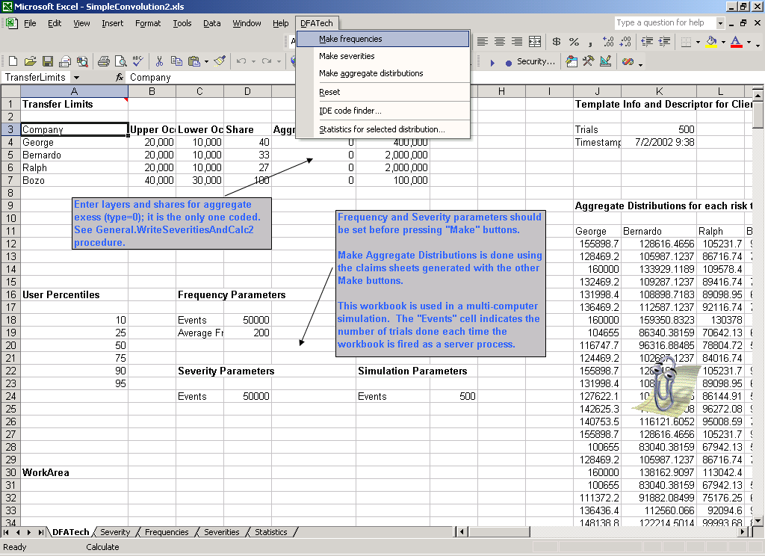

Burville.xls: Exercises in Range Specification, Use of Excel’s VLOOKUP
When John Burville and I were talking one time, he expressed an idea for achieving finer probability granularity when simulating from a discrete distribution. The Burville.xls workbook contains his methodology. The approach is to put a placeholder for the x value of an interval in which finer granularity is desired. When this placeholder is observed during a simulation, another draw is taken from the conditional, finer granularity associated with the interval. The advantage of this approach stems from a very old trick of loading an array with x values in proportion to their interval probability. Then, simulation involves the generation of a uniform integer over the length of the array. That integer directly addresses an element of the array, and, hence an inverse function x value. John’s method allows one to achieve finer granularity in certain portions of the distribution without using one, giant array at the lowest level of granularity. E.g., .001 granularity is achieved with an array of 1,000 elements. However, if another 100 element array is setup for an interval, f(x), then granularity of .0001 can be obtained. This is a useful mechanism for simulating small probabilities in tail regions.

Because the Burville technique necessarily requires detection when the placeholder is observed and a second-stage simulation, there is required logic. This logic can be put in cell formulas, however, it is significantly slower than doing the simulation with VBA code.

Using VLOOKUP is a special way and VBA code containing the necessary logic for the Burville approach, one is able to generate random numbers for just about any distribution very fast.

Figure 3 Menu for Burville.xls
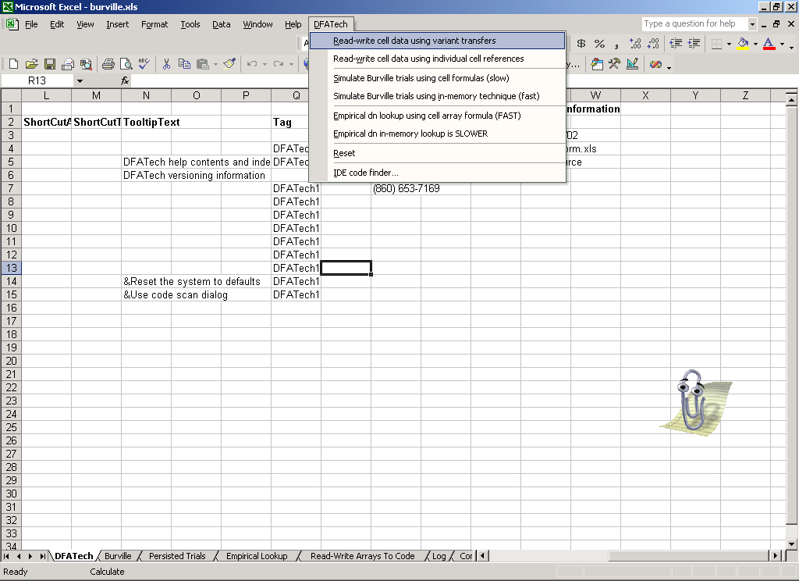

MultiPlatform.xls: Using MSMQ for Multiple Computer, Excel Simulations
This application uses advanced Excel techniques. The theory, however, is comparatively simple. It is outlined in the following notes. However, if you want detailed information on its implementation, please contact me.

MSMQ is Microsoft’s Message Queue system; it is available on all supported Microsoft Windows systems. MSMQ has a excellent class foundation and object support both for handling rich message content and for the asynchronous notification of receipt of a message to an application from another process running on the same or another computer.

A registry private queue is maintained and all computers can talk to it because its address is embedded in the workbook’s DFATech system sheet. This registry queue is populated with information about the separate private queues for all the participating servers. Were the operating system environment to support Active Directory, a public registry queue could be used, and a grid of participating computers can exist beyond the LAN on the web.

The idea is to have a computer on the LAN whose name can be embedded in a workbook’s system information serve as a hub queue, not for dissemination of information of simulation data but, rather, to tell a client where it can attach to servers. MultiPlatform.xls is written both as the client and as the server application. Once it is opened in Excel it can be used as a client to run a multi-computer simulation; so any computer on the LAN can be the launch point of a simulation. Of course, other computers must have MultiPlatform.xls running in an Excel process and be registered in the Registry queue.

Once a server’s private queue is identified, the client can bundle and send messages. This messaging operation is done using MultiPlatform’s MQ class object. This object is instantiated WithEvents so that when the server’s private queue gets a message, an event is fired and the MQ object can unravel the message, route it and perform the required work.

Figure 4 Menu for MultiPlatform.xls
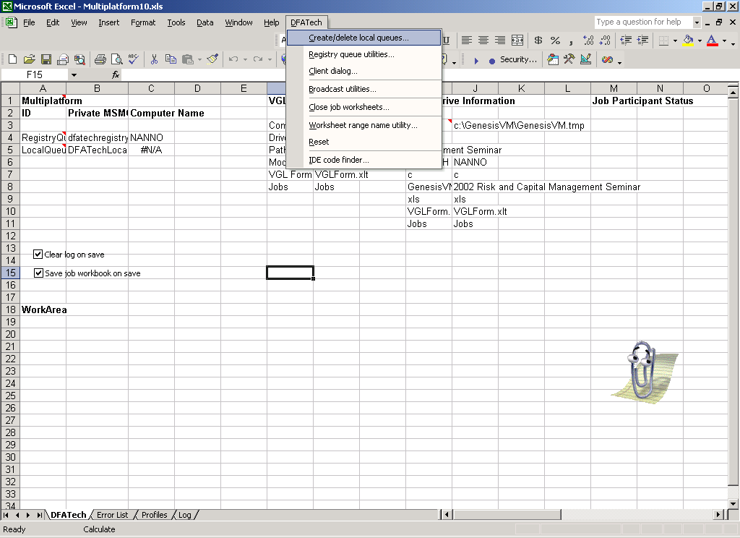

Setting Up MSMQ
Activation of MSMQ is generally beyond the scope of this discussion, and must be done with Administrator access privileges to the computer. The first step is to open the Control Panel.Add/Remove Programs. A dialog similar to the one shown below will appear; press the Add/Remove Windows Components button in this dialog.
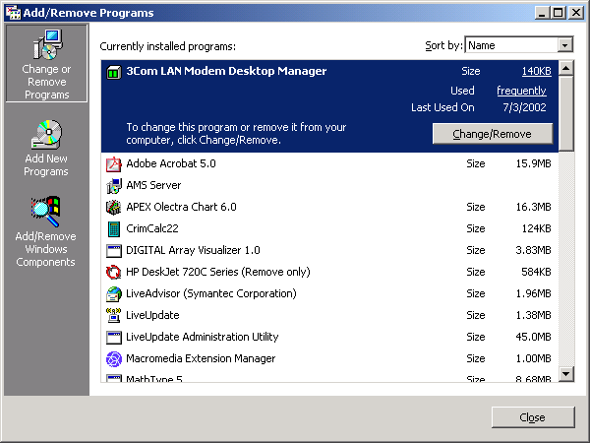

The Windows Comonents Wizard is similar to the dialog shown below. It has been scrolled to the Messages Queuing Services checkbox. You need to assure that it is checked, and then MSMQ will be installed when you progress through the “Next” buttons. You will need Administrator privileges, and may need a Windows system CD.

You need to be able to run independent queues that are private.
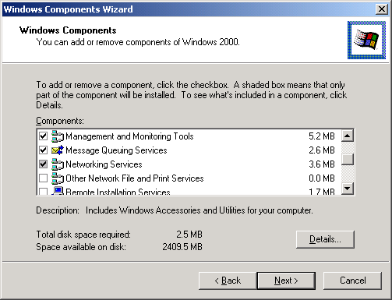

Setting Up the Registry Private Queue
Decide on the computer that is to be used for the location of the Registry MSMQ queue. The following operations are done on that computer.

If you are running Windows 2000 or Windows XP, use Control Panel.Administrative Tools.Computer Management. The latter is a management consol snap-in, compmgmt.msc, and probably located in the Windows System32 folder.

The Registry queue must have a name that will be known to the Excel application. The name appears in a cell in the DFATech worksheet. As of this writing, that name is DFATechRegistry. The snap-in dialog is similar to the one shown below.
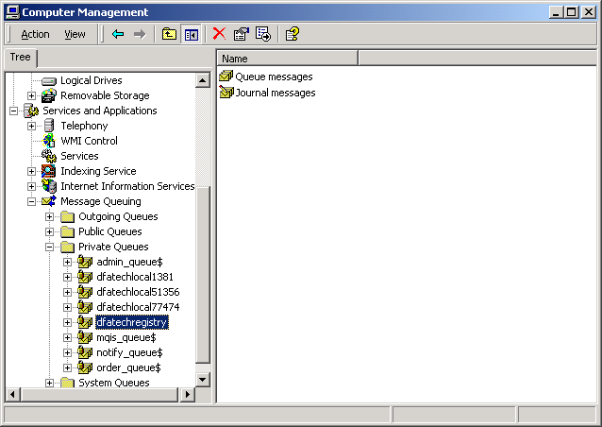

To make the private queue, do a right mouse click on “Private Queues,” select New.Private Queue. This operation is illustrated in the desktop screen shot shown below.

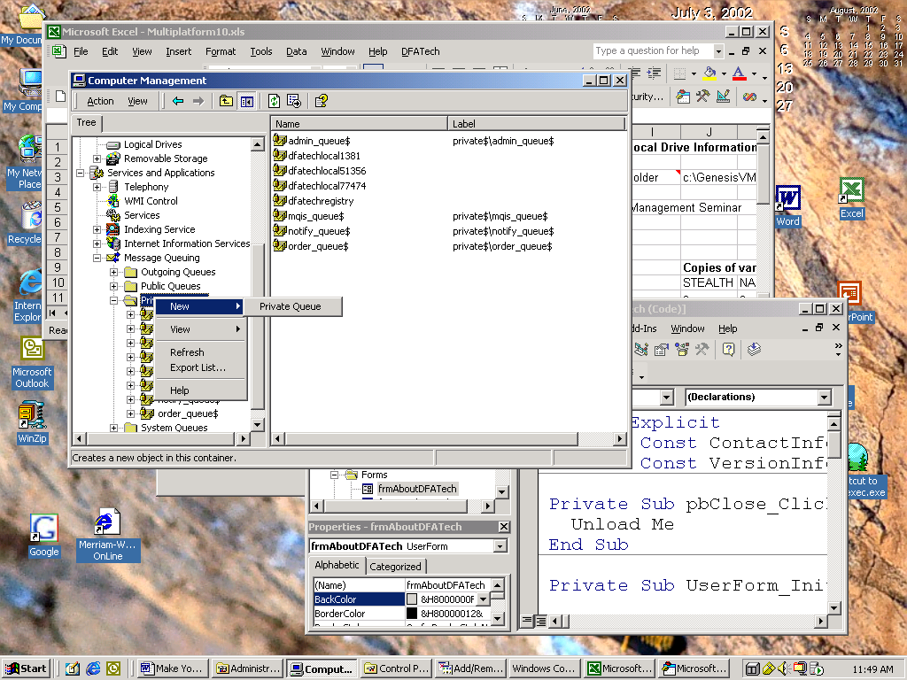

Setting Up MultiPlatform.xls
The first thing is to assure that the workbook is vectored to the right locations. The screen shot below shows the operative sections of DFATech worksheet. The example indicates that the location of the Registry queue is NANNO.
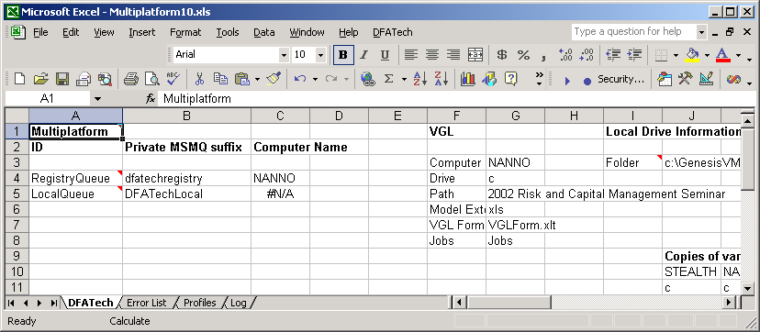

Setting Up the VGL
The application uses a folder that each computer must have write permissions for the logged on user. The drive should be a mapped drive, which can be created within File Explorer by right-clicking on the folder. Both the name of that computer, its mapped drive letter and the folder path (exclusive of drive letter) are provided in the VGL range.

Creating a Local Queue on a Server
The Multiplatform.xls application must be running on the server in Excel. The menu item, Create/Delete Local Queues should be pressed.
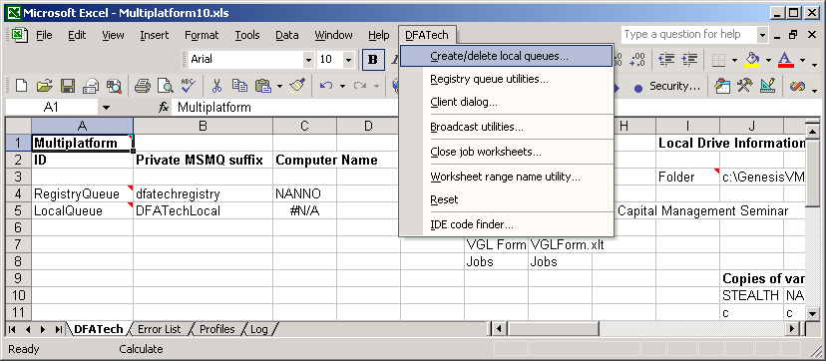

A dialog similar to the one shown below has an option to create such a queue. You should run one of the delete queue options first.

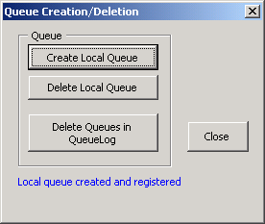

To assure that the queue is operational, you may want to use a utility to “ping” it. On the main menu, choose Registry queue utilities.

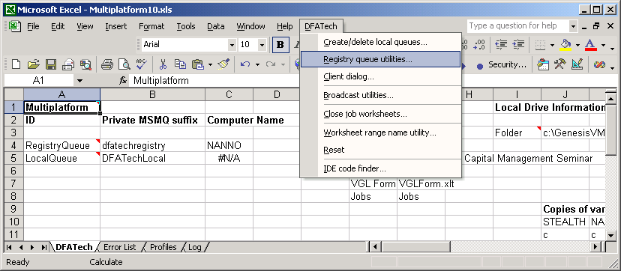

A dialog similar to the one below will appear. You can use the ping button, and if MSMQ is active and both the Registry and Local queues have been properly set up you will get a response after a short delay.
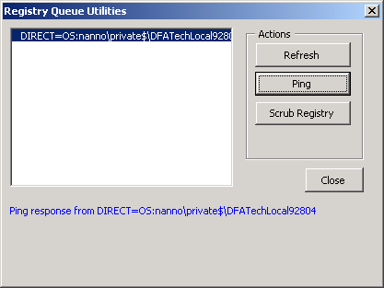

Prior to running any bootstrap menu items, you should have constructed the claims data (or imported a similarly organized rectangular, exogenous set of claims data) in the “Data” worksheet.
Message content, for example, can be a binary image of a workbook, XML and other content. In Multiplatform, the latest version of the server’s slave worksheet that does the simulation work (SimpleConvolution.xls) is ported to servers within a message. The server need not have knowledge of the whereabouts of this workbook to participate in the multiple computer simulation.
A participating server is a machine on which a user has opened Multiplatform.xls in Excel and registered itself in the Registry queue using menu options for that purpose. There can be many such server nodes on the LAN.
The computer management snap-in is very useful for examining queues. It is essential for making the Registry queue, which is just a private queue with the special name. But, it also is useful to examine the contents of queues. You should make a shortcut for this on your desktop.

