Chapter 6 - Underwriting and Pricing Risk

6.0 Introduction

Dynamic risk modeling in a simple form can be used to estimate stochastic cash flows of an individual policy or treaty in order to perform pricing analysis. This form of modeling is often used for estimating the impact of structural elements such as annual aggregate deductibles, sliding scale commissions, loss corridors, aggregate limits, and profit commissions.

More advanced forms of dynamic risk models can be used to measure the volatility in the underwriting results of a portfolio of insurance policies. This could be a single line of business, or the portfolio of the entire company. Such an analysis requires assumptions regarding:

- the amount of premium to be written, earned and/or collected,
- the fixed and variable expenses associated with the portfolio
- the aggregate distribution of losses
- the timing of the premium, expense and loss cash flows
- an appropriate rate to discount the cash flows
- the correlations or dependencies between lines of business
- the impact of or interaction with other economic variables

In addition, we must choose an appropriate timeframe over which to model the business.

6.1 Parameterization of Loss Distributions and Payment Patterns

Introduction

In determining the parameters of a dynamic risk model, we use reserve, planning, investment information, asset holdings and reinsurance programs of the company. Once parameterized, we run iterations of possible company outcomes. This section will focus on the parameterization of loss distributions.

The main objective of fitting loss distributions is to characterize the loss generating process underlying the sample data that is being analyzed.

Among many possible loss distributions that can be used, the most commonly used are Normal, Lognormal, Pareto (including one, two and three parameter variations), Weibull, Gamma and Log-Gamma. Where individual claims will be modeled the distribution of claim counts is often assumed to be either Poisson or Negative Binomial.

Fitting a loss distribution achieves two important results. First it reduces the effect of sampling variation in the data, and replaces an empirical distribution with a more smoothed distribution. Second, it allows for the estimation of tail probabilities outside the range of the original data. Once we consider and select from among possibly suitable probability distributions, we proceed to estimate the parameters for this distribution.

It is important to fit loss distributions to segments of risk that display homogenous characteristics. Rating variables may be a useful tool in determining which segments to treat separately for this purpose. However, the level of segmentation should be weighed against loss of credibility as we define smaller segments of business.

While parameterization is an important first step in determining the risks associated with loss costs, we should avoid excessive parameterization for the following reasons. First we should be mindful of the cost associated with increasing the number of parameters to be monitored.

Second, we should carefully gauge the marginal level of accuracy to be gained by introducing more parameters in the interest of imitating the underlying losses. It may well be that the underlying data is incomplete and inaccurate, rendering the addition of more parameters inefficient in attaining more accuracy.

Third, we should be mindful of the fact that the results of the DRM process are often to be used by audiences that may not be extensively familiar with statistical approaches. For such users, a more manageable scope of parameterization will be helpful in rendering the analysis results more understandable, which should increase acceptance. It is imperative that we align very closely with business needs in the parameterization process.

Use of Company-specific and external data

One of the important decisions is to determine the extent to which company-specific versus external data are to be used. In determining the key parameters of the model, we must distinguish between those factors that depend on external events, and those that rely more heavily on company-specific information. For parameters that cannot be controlled by the company, such as interest rates and inflation, it may be more appropriate to rely on industry information. For dynamic elements that are influenced directly by company decisions, such as exposure and expense growth, it is more appropriate to rely on company data and management expectations. The kind of distinctions we may capture by using company-specific data relate to the particular insured base of the company, the specifics of the coverage that they offer, and the operations that they implement in trying to establish more streamlined claims handling processes.

It is also possible to use a combination of industry and company specific data for setting a parameter. For example, we can set the baseline payment pattern based on industry data, while determining the variability on each incremental payout percentage from actual company data.

Another important data issue is completeness of the data sample, which will determine the ease of estimating loss distribution parameters, or assessing goodness of fit. Our preference between company and industry data may take into account the level of completeness of the dataset.

Impact of policy limits, deductibles, attachment points

Policy limits and deductibles serve to limit the payments on a loss occurrence. They help define the distribution of losses paid by the insurer, based on the losses incurred by the insured. We can treat deductibles based on data truncation and policy limits as data censoring, and proceed to use maximum likelihood estimation to determine the parameters of our distribution.

We must recognize the variability in the magnitude of policy limits and deductibles by line of business. For example, deductibles for personal lines may be fairly small, whereas those for large insureds will be significant. There may also be variability in the terms of application of limits and deductibles. For example, while a deductible ordinarily erodes part of the policy limit, self-insured retention does not. Such variability may serve to define the loss segments to be modeled separately.

Parameter uncertainty

The main cause of parameter risk as related to defining loss distributions to price insurance policies is the fact that prices of insurance policies are determined before coverage is offered and loss events occur. The level of risk is greatest at the inception of the policy, and gradually declines as claim information becomes available.

In estimating parameter risk, theoretical approaches as well as bootstrapping techniques can be used. We must recognize that multiple sets of parameters can produce the actual sample data, and it is not possible to determine which set exactly represents the underlying distribution.

Parameter uncertainty may arise from sampling of loss ratios, loss development, on-level factors underlying these loss ratios and the choice of underlying distribution. One way to handle sampling uncertainty is to make appropriate adjustments to the choice of underlying distribution.
The normal, beta, triangular and uniform distributions are commonly used to model uncertainty in the
parameters of assumed loss distributions.

As opposed to using the best-fit distribution, it is prudent to incorporate the error structure of sample-based parameters. The best way to do this is to define the tolerance level for the probability that the parameter value falls within a certain range. The key is to be able to encompass a range of reasonable choices for the parameter value, so as to capture all the pertinent information from a sample. This approach will manifest itself in the results of pricing applications as higher pure premiums, and higher frequency and severity indications for downside risk measures.

Choice of discount rate

Often the complete model of the enterprise will include explicit modeling of the investment portfolio for the enterprise in order to capture the market and credit risk inherent in the investment portfolio. However, if one desires to explicitly measure the performance of the future underwriting, one will need to make an assumption regarding the investment income earned on future underwriting cash flows. A common way to achieve this is to discount the underwriting cash flows to their present value at an appropriate rate. This is complicated because the timing of the cash flows is not known with certainty. Also, the available yield at some future point when premiums will be collected, and therefore available to be invested, is also uncertain.

A reasonable approach to handling the uncertainty regarding the timing of the cash flows is to assume that premiums will be invested at an appropriate treasury spot rate with the expected timing of the loss or expense payment. Another approach would be to assume funds are invested in 3-month T-Bills and continuously reinvested at the then prevailing T-Bill rate until the funds are needed to pay losses. An implicit assumption herein is that treasury bills/bonds are a risk-free investment. By that we mean that they are completely liquid and have no chance of default.

The timing of loss and expense payment can be determined from varied sources of data history, which we usually triangulate in summary form by the year coverage was offered or the year that the loss event occurred. Once an appropriate pattern is selected, it is applied to liabilities by coverage year to derive the projection of expected future cash flows. We generally prefer to use loss experience gross of ceded reinsurance. Gross cash flows for a company are likely to be longer than the net cash flows. Furthermore, changes in the reinsurance arrangements of a company may create undue distortion in the net development patterns.

We can use the output of an economic scenario generator in order to estimate future yield rates. Economic scenario generators use a variety of underlying models in order to generate probability weighted future scenarios with regard to a variety of economic variables – treasury yields for various currencies, inflation rates, credit spreads, equity returns, etc. The modeling and parameterization of economic scenarios is beyond the scope of this chapter.

Impact of inflation / loss trend on payment pattern

It is understood that inflation will impact the ultimate settlement amount of individual claims. However, the link between commonly used measures of inflation and the impact on insurance claims is not obvious. Certainly various forms of social inflation such as increases in jury awards or changes in the tort laws can have a significant impact on the size of insurance claims. But, to the extent that the severity trend in loss payments can be modeled as a function of commonly used inflation indices, one will improve the overall accuracy and usefulness of the dynamic risk model. Through the use of an economic scenario generator, we are able to cohesively tie together the prevailing interest rates with the underlying inflation rate – the two being closely correlated. In this way we can model the dependency of ultimate loss amounts with total investment returns.

Loss trend is comprised of frequency, severity and exposure trends. In determining the loss payment patterns, we must be careful to identify inconsistent changes in frequency, severity and exposure growth, and make suitable adjustments to historical data.

We are charged with the task of defining a statistical curve that reflect changes in historical loss data, in other words trends. For this we examine the time series of internal company and external economic data in an effort to identify a consistent relationship.

Trend patterns observed in historical data are generally presumed to continue in the future. However, their continuity should be reviewed periodically. In addition, we must determine the relationship of trend with various claim sizes. We must ascertain if inflation affects all loss sizes equally, or if separate trends can be observed in different sizes. One must be mindful of the impact that a change in frequency of claims by size can have on the observed change in the size of losses. For example, an increase in the frequency of small claims could lead one to conclude that the increase in the severity of claims is more muted than may actually be the case. See Feldblum, “Varying Trend Factors by Size of Loss” for a more thorough exposition of this topic.

Intuitively, larger claims are liable to get influenced more acutely by trend effects. However, we must go beyond how inflation and other trends affect the loss sizes individually, to how they actually impact the loss distribution itself.

6.2 Choice of Timeframe and Consideration of Market Cycle

Length of Underwriting Period

The timeframe chosen with regard to underwriting period will be dependent on the desired use of the model outputs as well as the planning cycle of the enterprise. Underwriting period as used here can denote an accident year, a policy year, treaty year or some other measure relative to when business is written or earned. One possibility is to model only business that has already been written, but not yet earned. This would essentially mean that we are modeling the uncertainty in the adequacy of the unearned premium reserve. Another common approach would be to model business to be written or earned over the subsequent 12-month period. This coincides with the normal planning/budgeting period of many insurance firms.

Forecasting beyond 12 months will add considerably to the uncertainty with regard to the amount of premium that will be written, the underlying rate adequacy as well as changes in the underlying loss costs. Nevertheless, many firms will devise three or five year plans and it can be very informative to build a dynamic risk model based on those static planning scenarios. In designing dynamic risk models that span several years one can and should explicitly model the impacts of the insurance pricing cycle. Whereas we are not able to accurately predict the movements in the insurance market, just as we cannot predict movements in the stock markets or bond markets, we are able to make reasonable assumptions about what might happen by studying the past. This is an important driver of overall underwriting results and also an important factor in the correlation of results between lines of business. One can also build management actions into a longer-term model to account for actions that would be taken given changes in underlying market conditions. This will add considerable complexity to the model, and one must be careful to be certain that the anticipated management reactions are reasonable and realistic.

Length of Projection Period

Separate from the choice of length of underwriting period is the choice of the length of the projection period. One may choose to model all cash flows to runoff, or it may only be necessary to model the impact to the company over a one year time horizon. Generally the losses will be simulated based on their ultimate settlement value and determining the estimated payment pattern and the estimated incurred loss pattern is tackled separately. Designing a model to cater for the recognition of the difference between the simulated ultimate loss scenario and the a-priori expected loss amount is challenging. One possible solution is to simulate the incremental addition to the loss triangle and then apply a mechanical reserving process to the new loss triangle with the additional diagonal. See Wacek, “The Path of the Ultimate Loss Ratio” for further exposition of this idea.

6.3 Modeling Losses

The way in which losses are modeled will in part depend on the purpose of the model. If, for example, we desire to use the model to analyze the desirability of an excess of loss reinsurance placement, we will need to model individual large losses. Generally we have a choice of modeling losses in the aggregate, modeling individual risk losses and modeling clash/catastrophe losses (i.e. those events that impact more than one insured).

For segments of business that can be significantly impacted by one or few large losses, one should model individual large losses. For a line that has a high frequency of small losses (for example personal auto), it may be sufficient to model loses in the aggregate.

In some instances, the makeup of the policy/treaty attachment points or retentions and the policy/treaty limits can have a significant impact on the shape of the resulting loss distribution. Therefore, it might be appropriate to model losses in a way that explicitly considers the policy profile.

Clash/catastrophe losses should be modeled separately as their existence can have a significant impact. It is also important to properly model the implicit contagion that such events have within an insurers underwriting portfolio. (Re)insurers that write a significant amount of cat exposed property business will likely use a specific catastrophe model in order to simulate the impact of catastrophic events on their portfolio of insured risks. While each such model is unique the general approach are broadly similar. A given event (for example a specific windstorm with certain characteristics relative to wind speed and storm track) is assumed to occur with a certain probability. Given the occurrence of this event, the ground up loss to risks within the insurer’s portfolio can be estimated and the specific policy features (deductibles, limits, coinsurance, etc.) applied to the ground up loss in order to determine the insured loss. Such an approach allows insurers to estimate the overall impact that catastrophes can have on the company.

6.4 Correlation between Lines or Business Units

Insurance price levels are affected by many factors, both internal and external to the company. External factors include such things as the competitive environment of the insurance market, general price levels in the economy, prospects for investment income, and the judicial and regulatory environments. Internal factors include a company’s desired rate of return, appetite for growth, and operational changes. Often, the factors affecting price levels will have a tendency to affect multiple areas simultaneously. For example, a new market entrant may lead to increased price competition in some lines. Changes in expected inflation may affect prospective loss costs for all lines of business, as well as affecting carried reserve levels. A desire to increase premium volume may lead to aggressive pricing for several lines of business. Changes in company operations may affect prospective costs for some lines, while leaving others unchanged. A realistic dynamic risk model must reflect this tendency for prices to move together.

Correlation is a measure of the relationship among two or more variables. Some measures of correlation commonly used in dynamic risk modeling are Pearson’s correlation coefficient, Spearman’s rank correlation coefficient, and Kendall tau rank correlation. These are measures of the linear relationship between variables. The assumption of a linear relationship is usually sufficient in a dynamic risk model. If, for a particular model, this approximation is not sufficient, the measurement and modeling of correlated variables can be much more involved. Techniques used to model non-linear relationships include transformation of variables, polynomial fits, or piecewise linear approximations, but these techniques will not be discussed in this handbook.

Pearson’s correlation coefficient

Pearson’s correlation coefficient is the most commonly used measure of correlation. When discussing correlation without any further specificity, Pearson’s correlation coefficient is typically what is being referred to. It also may be familiar as the square root of the coefficient of determination R^2 from a least squares linear regression.

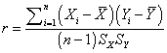

Pearson’s correlation coefficient produces a measure of correlation between -1 and 1. Variables with no relationship between them (independent variables) produce a value of 0. If one variable increases as another variable increases the coefficient will be between 0 and 1 (positive correlation). If a variable decreases as another variable increases the coefficient will be between 0 and -1 (negative correlation).

There are several assumptions underlying the Pearson coefficient calculation that are not met in an insurance company model. The relationship between the variables is assumed to be linear and the distributions are assumed to be normal with a constant variance. Another drawback is that the correlation is highly affected by outliers.

The following scatter plot charts show the relationship between two identically normally distributed variables under different dependence structures.

This first chart shows the relationship when the two distributions are independent of one another. Though, bear in mind that a correlation coefficient of zero does not necessarily imply independence.

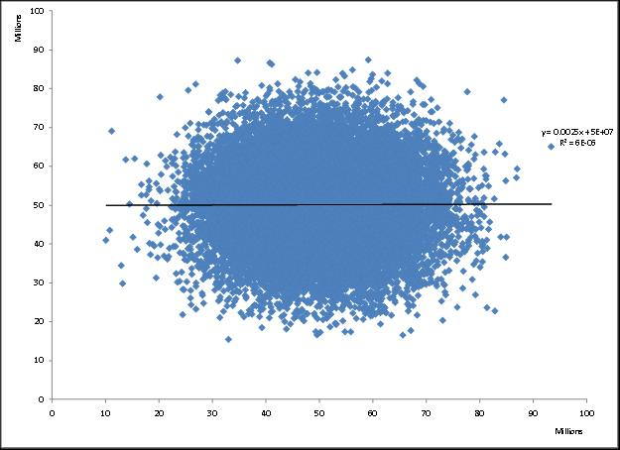
The next chart shows the relationship when a normal copula is used to induce correlation (50% as measured by the Pearson correlation coefficient).

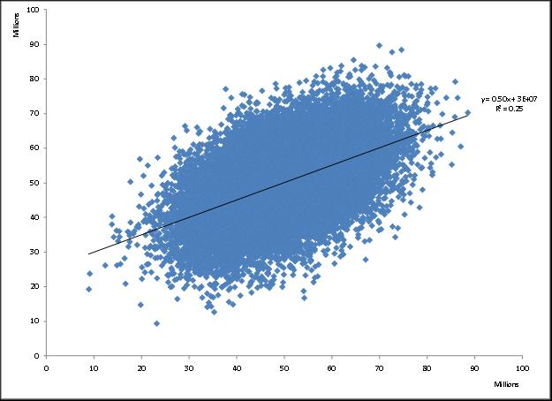
The last chart shows the relationship when imposing a Gumbel copula. The Pearson correlation coefficient is also 50% in this example, but one will notice that the dependence in the tail is stronger. That is, large values are more likely to be associated with large values.

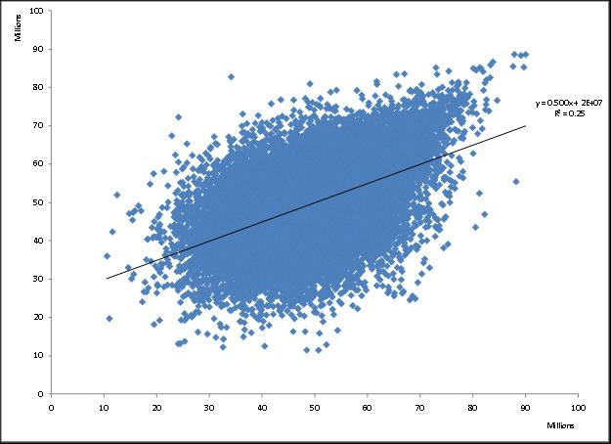
Rank correlation coefficients

Spearman’s rank correlation coefficient and Kendall tau rank correlation coefficient are non-parametric rank correlations. They have two main advantages over the Pearson coefficient. First, as non-parametric calculations, they do not assume a distribution for the variables. This is a major advantage because dynamic risk model variables are often not normally distributed
. A second advantage is that they are based on the correlation of the ranks of the variables rather than the values of the variables. The advantage here is that extreme values cannot distort the calculation of the correlation. As insurance company models often have variables with extreme values, this is another major advantage for the rank correlation coefficients.

Spearman’s rank correlation

Spearman’s rank correlation is calculated using the same formula as the Pearson coefficient, but using the ranks of the variable outcomes instead of the values.

Kendall tau rank correlation

Kendall tau rank correlation is also calculated using the ranks, but uses a formula which depends on how many of the ranks are in the same order.
Kendall’sTau = 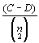
Where
C = Number of pairs that are concordant.
D = Number of pairs that are not concordant
Any pair of observations (x_{i}, y_{i}) and (x_{j}, y_{j}) are said to be concordant if the ranks for both elements agree: that is, if both x_{i} > x_{j} and y_{i} > y_{j} or if both x_{i} < x_{j} and y_{i} < y_{j}.
They are said to be discordant, if x_{i} > x_{j} and y_{i} < y_{j} or if x_{i} < x_{j} and y_{i} > y_{j}.
If x_{i} = x_{j} or y_{i} = y_{j}, the pair is neither concordant, nor disconcordant.

Using Correlation in Dynamic Risk Models

There can be many elements within a dynamic risk model that are correlated and the practitioner should take care to make sure such dependencies and correlations are properly considered and modeled.

If one is forecasting more than one year, one should make sure that there is serial correlation across years. This is true not only for movements in economic and financial market variables, but for insurance market movements as well. One will also need to make a determination of how to associate movements in the insurance variables (premium volumes, expected loss ratios, expense ratios) with other variables such as GDP growth, inflation, interest rates, etc.

Of course, the correlation of losses or loss ratios between lines of business is of critical importance. There are many reasons why losses will be correlated across lines or segments. To the extent we understand the underlying causes of dependence and are able to directly model these causes, this is preferable to superimposing a correlation without understanding the causative reason behind the correlation. Losses can be correlated because a single event such as an earthquake can cause losses to many policies/segments at once. Another reason losses will be correlated will be because of shifts in inflation or tort law that will impact more than one underlying line or segment of the insurer’s business. A third reason for correlation in loss ratios across lines or segments is that rate adequacy tends to move together across the entire spectrum of property and casualty insurance market.

Another consideration should be the correlation of reserve adequacy and future underwriting profitability. This correlation is also linked to the movements in the insurance market cycle discussed previously. Generally speaking, loss reserves become increasingly deficient toward the tail end of the soft part of the market cycle. Rates will then rise, perhaps dramatically, leading to improvements in prospective profitability. Reserves are strengthened and current accident year ultimate loss ratios are over-estimated, eventually leading to redundancy in loss reserves. Rate adequacy will peak and then gradually fall. At some point reserves are released, accident year initial loss ratios are set too low and the cycle continues.

Bouska, Amy S.; “From Disability Income to Mega-Risks: Policy-Event Based Loss Estimation”
http://www.casact.org/pubs/forum/96sforum/96sf291.pdf

Butsic, R ; “The Effect of Inflation of Losses and Premiums For Property-Liability Insurers”
http://www.casact.org/pubs/dpp/dpp81/81dpp058.pdf

Casualty Actuarial Society ; “Fair Value of P&C Liabilities: Practical Implications”
http://www.casact.org/pubs/fairvalue/28.pdf

Feldblum, S.; “Varying Trend Factors by Size of Loss”
http://www.casact.org/pubs/forum/88fforum/88ff011.pdf

Guiahi, F.; “Fitting to Loss Distributions with Emphasis on Rating Variables”
http://www.casact.org/pubs/forum/01wforum/01wf133.pdf

Hayne, R, M ; “Modeling Parameter Uncertainty in Cash Flow Projections”
http://www.casact.org/pubs/forum/99sforum/99sf133.pdf

Hayne, R. M., “An Estimate of Statistical Variation in Development Factor Methods,” Proceedings of the Casualty Actuarial Society 72, 1985, pp. 25-43, http://www.casact.org/pubs/proceed/proceed85/ 85025.pdf.

Kauffman, R ; Gadmer, A ; Klet Ralf ; “Introduction to Dynamic Financial Analysis”
http://www.casact.org/library/astin/vol31no1/213.pdf

Kirchner, G. S. ; Scheel, W. C. ; “Specifying the Functional Parameters of a Corporate
Financial Model for Dynamic Financial Analysis”
http://www.casact.org/pubs/forum/97sforum/97sf2041.pdf

Kreps, R. E., “Parameter Uncertainty in (Log)Normal Distributions,” Proceedings of the Casualty Actuarial Society 84, 1997, pp. 553-580, http://www.casact.org/pubs/proceed/proceed97/97553.pdf.

Mango, D. F. ; Mulvey, J ; “Capital Adequacy and Allocation Using Dynamic Financial Analysis”
http://www.casact.org/pubs/forum/00sforum/00sf055.pdf

McClenahan, C ; “Adjusting Loss Development Patterns For Growth”
http://www.casact.org/pubs/forum/87fforum/87ff155.pdf

Meyers, Glenn G., "The Common Shock Model for Correlated Insurance Losses," Variance, Volume 1, Issue 1, 2007, pp. 40-52.

Rosenberg, S; Halpert, A.; “Adjusting Size of Loss Distributions for Trend”

http://www.casact.org/pubs/dpp/dpp81/81dpp458.pdf

Struppeck, Thomas, “Correlation”, Casualty Actuarial Society Forum 2003: Spring, pp. 153-176

Underwood, Alice and Zhu, Jian-An, “A Top-Down Approach to Understanding Uncertainty in Loss Ratio Estimation,” Variance, Volume 3, Issue 1
Van Kampen, C. E. ; “Estimating the Parameter Risk of a Loss Ratio Distribution”
http://www.casact.org/pubs/forum/03spforum/03spf177.pdf

Venter, Gary, “Tails of Copulas,” Proceedings of the Casualty Actuarial Society, 2002: LXXXIX, pp. 68-113

Wacek, Michael, “Parameter Uncertainty in Loss Ratio Distrbutions and its Implications,” Casualty Actuarial Society Forum, Fall 2005, pp. 165-202, http://www.casact.org/pubs/forum/05fforum/05f165.pdf.

Wacek, Michael, “The Path of the Ultimate Loss Ratio Estimate,” Variance, Volume 1, Issue 2

Wang, Shaun S., “Aggregation of Correlated Risk Portfolios: Models and Algorithms,”
Proceedings of the Casualty Actuarial Society, 1998: LXXXV, pp. 848-939.

