Help Guide for High Performance Computing (HPC) Dynamo Version 5.0

By
William C. Scheel

Contents
Introduction 5
Operation without HPC 5
Figure 1 HPC Non-Activation Dialog 5
Required Knowledge—Visual Basic for Applications (VBA) 6
HPC in Brief 6
Data Routing in HPC 7
HPC_xxx: Callback VBA Functions for HPC Jobs 8
What’s New in HPC Dynamo? 9
New Tools 9
Right-Click Menus 9
Right-Click Reference Convention Used in this Guide 10
Dialogs 10
Worksheet Navigation 10
Add DFA Variable 14
Pod Workbooks and Pod Setup Dialogs 15
Keep Textboxes In Place 16
Random Variable Generation in HPC Dynamo 17
Creating a Pod 18
Choosing Pod Variables 19
Pod Mapping 22
Random Number Generation 23
HPC Dynamo Uses Variable Decoration to Redefine Random Numbers 23
Formulas Resulting in #DIV/0! 25
Table 1 Propagation of #DIV0! Errors 26
Figure 17 Using Formula Navigation Dialog to Track SUM Formulae with #DIV0 Values 27
Statistics 27
CreateStatisticsTable 27
Value at Risk (VaR), Tail VaR and Expected Policyholder Deficit 28
Graphics 28
Figure 18 Example of a Dynamo Graphic for a DFA Variable 28
Graphics Cleanup 29
Reserved Words, System Worksheets and Restricted Ranges 29
Reserved Words and Variable Name Decorations 29
System Worksheets and Titling Conventions 29
DFA Variable Names 29
Hot-Key Navigation 30
Running a Model and Working on a Model 30
Adding New Lines of Business 31
Output Setup 31
Figure 19 DFA Variable Setup 31
Systems Setup 32
Table 2 System Parameters 32
Run Setup 36
Figure 20 Test Harness Dialog for HPC Run Launch 37
The Importance of Random Variable Decoration 37
Original Model Simulation Mode 38
Setup Deterministic Workbook 38
Using Dynamo in Microsoft HPC Clusters 38
Head Node and HPC File Share 39
HPC Resource Specification 39
High-volume HPC Simulation Tuning 39
Using HPC Cluster Manager 40
Recovery of Simulations from a Drained State 41
Figure 23 Cluster Manager Job Details 42
Using Dynamo in Microsoft Azure 42
Figure 21 Setup for Azure Operation 43
Figure 22 Upload Package to Azure 44
Figure 23 Azure Deployment Health on the Azure Portal 45
Setting Up New Lines of Business 45
Introduction 45
Note on 3D References 46
Utilities 46
ShrinkToHere—Solve Workbook Bloat Problems! 47
Figure 24 ShrinkToHere Dialog 48
Auto Shrink All 48
Keep Textboxes In Place 49
Remove Bad References #REF! 49
Figure 25 Excel Name Manager Filtered Deletion Dialog 50
Appendix 1 Random Variable Generation in HPC Dynamo 50
Introduction 50
Appliances for Correlated Random Variable Generation 51
Appendix 2 Programming Notes Relevant for HPC 52
Knowing When a Workbook is Operating on a Compute Node 52
Appendix 3 System Procedures 53
Introduction 53
Table 3 Modules in Dynamo VBA Code 53
Appendix 4 Developer’s Notepad 54
Introduction 54
Cluster Starvation 54
Interaction between Dynamo and DFATech Pod Workbook.xlsm 54
Appendix 5 Links to Help Resources and Video Clips 56
Introduction 56
Steps for activating a “Link” 56
Links to Documents 56
Links to Video Clips 56
End Notes 57

Introduction
The primary motivation for writing a new version of Dynamo was to illustrate the use of high performance computing (HPC) Microsoft Excel 2010. On the way, many modifications were made to the original version. This document describes many of the changes. It does so only from a systems perspective. The reader is directed to the What’s New section. It has links to other parts of this document, and it serves as an overall summary of these changes.
If you are interested in documentation of the model rather than the system supporting model operation, please see http://www.casact.org/research/Dynamo_Manual.doc.

Operation without HPC
The HPC version has been designed to work both with and without HPC. HPC operation requires the installation of HPC Pack on your computer. And, the Visual Basic for Applications (VBA) code in Dynamo 5 uses a reference. When that reference is not present the code will not compile. If you want to use HPC and have installed the HPC Pack, you will need to do one further step in VBA code. There is a conditional compile flag that must be set either to False (no HPC) or True (HPC is installed). This conditional boolean turns sections of code on and off. If you have HPC, the boolean is ON and you will be able to use Dynamo 5 either in HPC mode or in its non-HPC Excel mode. When the boolean is OFF, you will see the dialog in Figure 1 when the workbook is opened.

Figure 1 HPC Non-Activation Dialog
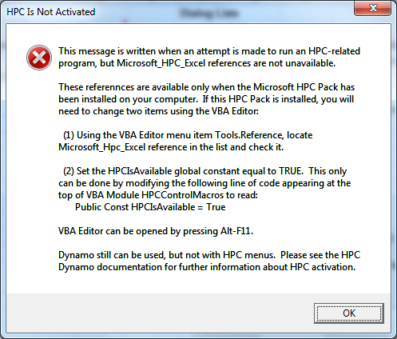
Unfortunately, there is no programmatic way to toggle the setting for HPC references. You must use the VBA editor (alt-F11), navigate to Modules and select HPCControlMacros module. The boolean appears at the top of the module in the declarations section of the module code.
By default, Dynamo is distributed without HPC activation. Once you have HPC Pack installed and an HPC cluster is available, you can easily switch the HPC boolean to equal True.

Required Knowledge—Visual Basic for Applications (VBA)
The prior section notes that HPC Excel requires the use of VBA and an understanding of VBA. Excel users will need to move beyond the use of the macro recorder and a limited understanding of VBA when moving into HPC Excel. This skill set becomes apparent in the next section when we take a peek under the hood. The author believes an intermediate to advanced understanding of the Excel object model is required, so the basic programming language must be supplemented with an understanding of the fundamental objects in Excel, including workbook, worksheet and range objects. These objects will be extensively used during the course of parallelization of a workbook so that it may be used on a cluster of computers.

HPC in Brief
A grid of computers can run many instances of Excel in parallel, so if a workbook can be opened in these instances, and recalculated in a coordinated fashion, a significant performance enhancement can accrue. Dynamo has always been a simulation model. When a user pressed the Simulation button, a macro runs that is, in effect, operating like a finger that repeatedly presses the F9-Calculate key. Each virtual finger press is a trial. Dependent cells in the workbook and volatile functions are recalculated to produce the results for a simulation. The calculation macro, of course, does activities other than Application.Calculate. But, this is its most important function. In addition, the Simulation button enters simulation-critical data before pressing the key (we shall call this a partition step). After the workbook is calculated using the partition data, the simulation button action reads the results and uses them in reporting DFA variable realizations and probability distribution(s) derivation (we shall call this a merge step). And, the overall simulation also does various initial and final operations (we shall call, respectively, the initialize and finalize steps).
The steps in this calculation process are separated in HPC Excel so that the user directs each one through callbacks that are made to functions written in VBA code. There is a deconstruction of the process—it is changed from a sequential one to an asynchronous one. That is, Dynamo originally did an entire first simulation before it started a second one. Trials proceeded from start to finish: 1, 2, 3, …. In HPC computing, the trials are started when HPC tells you to start them and it executes the trials using different computational resources. HPC_Partition is the step (and the name of a VBA macro function) when the user gets a signal from HPC that it is about to being the next simulation. Having requested a partition data element from the client computer Excel process, HPC gives it to another Excel process running on a compute node in the HPC cluster. Notice that were there to be, say, 200 compute nodes available, HPC could request 200 partitions for distribution before any compute node derives a result. And, there is certainly no guarantee that the results will be ordered in real-time completion in the same order that partitions were requested from the client. So, partitions rendered in an ordered set will not be calculated and returned in the same order. A compute node working on partition 18 could derive a simulation result before a different node finishes with the first partition. Why? The compute nodes may differ in computation resources, power and operational efficiency. Compute node 18 may be a very fast service node compared to 1.
And, because compute node 18 is fast, HPC can feed it another partition before it can feed one to compute node 1. How all of this is done is the magic of Microsoft HPC plumbing. But, it is important to understand that the order of results coming back to the client that submitted the HPC job have no expected order. This means that when a partition goes out, the data element must contain a cookie that is routed back to the client along with the results of the simulation. Why? The answer lies in how to match the original data with the result. The cookie could be as simple as a simulation number that goes with the partition data and is returned via the result being merged.

Data Routing in HPC
When a partition request is received by the client from HPC, a VBA function with this signature is called:
Public Function HPC_Partition() as variant
The VBA code fashions together whatever is in the variant, and HPC routes those data to a compute node running the same workbook. That compute node workbook has a function with this signature:
Public Function HPC_Execute(data as variant) as variant
So, the variant assigned during HPC_Partition on the client computer is the argument received in HPC_Execute on a compute node computer. The HPC_Execute function has full access to Excel resources. For example, it can put items in the data argument into workbook ranges and then calculate the workbook using Application.Calculate. During this same execution stream, the function might read a result of the calculation from a different range. This and/or other data can be put into the variant that is assigned to HPC_Execute.
The client receives the HPC_Execute variant during a subsequent call to the client’s HPC_Merge. It has this signature:
Public Function HPC_Merge(data as a variant)
So, data get routed from partition to execute, and then other data from execute to merge. Because these data are variables of type Variant, they can have any content or shape. They may be integers, doubles, strings or arrays. They cannot be objects because the data cross machine processes. And, they are limited to 64K in total size.

HPC_xxx: Callback VBA Functions for HPC Jobs
The functions that have been described in Data Routing in HPC are HPC callbacks. They entire set is described as follows:
- HPC_Initialize. The function is called once on the client instance. It is the first callback and may be used for setup activities prior to any subsequent callbacks.
- HPC_Partition. This function is called on the client instance to obtain data that is passed to a compute node that will then run HPC_Execute.
- HPC_Execute. This function is called on an instance of the workbook running on a compute node in this cluster. It receives data from HPC_Partition sent by the cflient. During HPC_Execute, the entire repertoire of Excel may be used. During this callback, the procedure may do range data insertions, calculate worksheets or any other activity, including calling other VBA macros. HPC_Execute prepares results of this activity as a data packet that is sent back to the client during HPC_Merge.
- HPC_Merge. This function is called on the client computer. It receives the results of HPC_Execute.
- HPC_Finalize. This function is called on the client computer and is the last callback. It may be used on the client computer to perform additional steps that cannot (should not) be done during HPC_Merge.

What’s New in HPC Dynamo?

This section describes modifications made to Dynamo Version 4.1. The authors decided to start with an implementation of that version that was used in Burkett, et al.

New Tools
Dynamo now has a right-click menu system. It is used for opening various dialogs and performing other activities. The right-click can occur on any cell within the workbook. This menu action is reset whenever a Dynamo workbook is opened and, in general, applies to that workbook only. One should be careful when attempting to run an Excel instance in which there is more than one HPC Dynamo workbook opened.

Right-Click Menus
The functionality of Dynamo is more easily accessed through the use of popup menus appearing when the user right-clicks on a cell. (Many keyboards have a button that will also display the menus rather than doing a right-click on a cell.) The right-click menu is extended from the regular selection in Excel to include new actions relevant for Dynamo. The modifications to the right-click popup only occur with a Dynamo workbook is open. An example appears in Figure 2

Figure 2 Right-Click Popup Menus
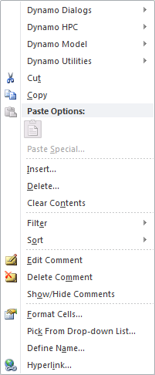
When the item “Dynamo Dialogs…” is selected, a second layer of popup choices appear. They are shown for the “Dialogs…” choice in Figure 3.

Figure 3 Secondary Dynamo Right-Click Popup Menus
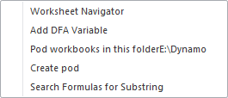

Right-Click Reference Convention Used in this Guide
We will use an italic reference to the above right-click menu items popups: <parent menu item>.<popup menu item>. For example, the Worksheet Navigator would be referenced in this text as Dynamo Dialogs.Workwheet Navigator. So, the leading item is what would be chosen in the right-click grouping and the second item would be chosen in its popup listing.

Dialogs
There are many new dialogs in HPC Dynamo. They are found by right-clicking in any worksheet cell and then selecting and navigating the Dynamo Dialogs popup. The dialogs serve various purposes including navigation, formula searching and DFA variable management.

Worksheet Navigation
There are two types of navigation dialogs. One is used for rapidly moving among worksheets within a workbook. The other dialog can be opened for any worksheet and moves among various “hotspots.”

Workbook Navigator
This dialog breaks down system worksheets into categories. You can navigate among worksheets rapidly and in an organized fashion. An example of the dialog is shown in Figure 4.

Figure 4 Worksheet Navigation Dialog
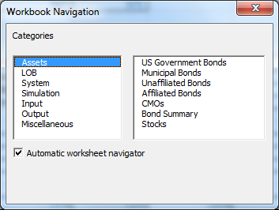
The contents of this dialog for navigation among worksheets are specified in the System worksheet in a table. An example of the table is shown in Figure 5. Please note that the worksheet names shown in Figure 5 must be spelled identically to their actual names. Users can modify this table if desired. Different categories can be used, and any given worksheet can be inserted into multiple categories. The Miscellaneous category, if present, will automatically list any worksheets not otherwise categorized.

Figure 5 System Entries for Worksheet Navigation Dialog
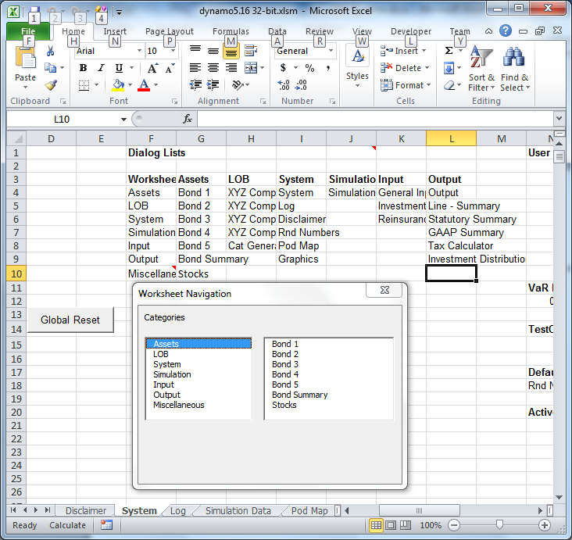

Worksheet Navigator
This is similar in appearance to the Workbook Navigator, but it enables rapid navigation to different “hotspots” within the selected worksheet category. A worksheet has a dialog navigation list similar in organization to Figure 5. The difference is that categories are broadly defined sections within the worksheet and the items are title cells appearing in the worksheet. The items on the right-side of Figure 6 are title cells within the XYZ Company – HMP –I worksheet in a category section called “Payment Pattern.” When an item is selected within a category, the worksheet is search for a constant cell containing that item. Typically, this would be a title cell. The cell cannot be a formula because only constant cells are searched. The first cell with a matching string is selected.

Figure 6 Example of Worksheet Navigation Dialog
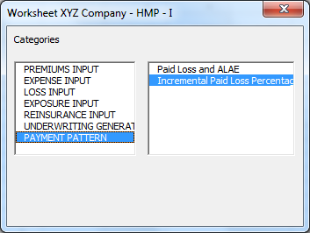
An example of the table that must be set up in a worksheet is illustrated in Figure 7. Note that categories are specified over the table top, and items for each category appear under it. The upper cell of the table body (under top row of titles) must have the range name “WorksheetTypes.” This table must be in the worksheet it is intended to be used for. It does not appear in the system worksheet which is where the workbook navigator table is located.

Figure 7 Portion of XYZ Company – HMP –I Worksheet Showing Dialog List
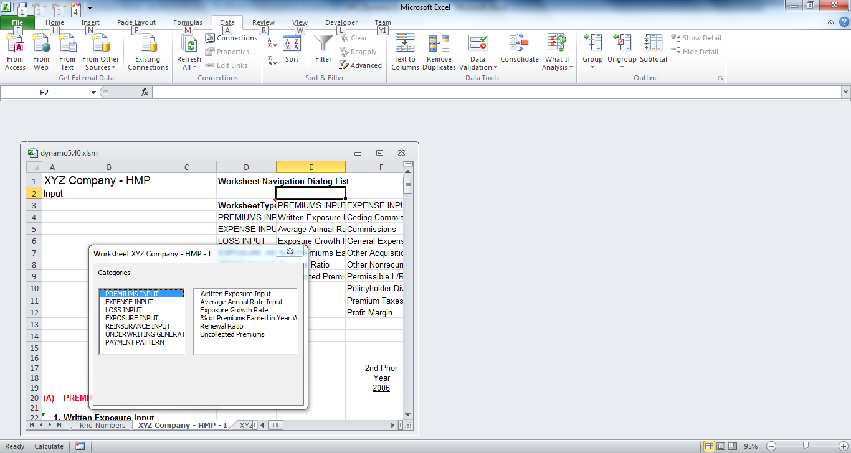
If the workbook navigator is open, a checkbox is available that will launch a worksheet navigation dialog automatically if it is available. This occurs when that worksheet is selected in the right side of the dialog.

Add DFA Variable
A new feature in Dynamo is a convenient method to add a calculated variable as a new DFA variable. A DFA variable is one appearing in worksheet Simulation Data. It has simulated results tabulated for an empirical probability distribution as well as statistical properties and risk metrics. For example, unearned premiums for a policy period appear in the Output worksheet. If you navigate to the cell and select it, the Add DFA Variable dialog will be similar to Figure 8. When this dialog is active and you select different cells, the fields will be automatically updated to the selected cell.

Figure 8 Add DFA Variable Dialog
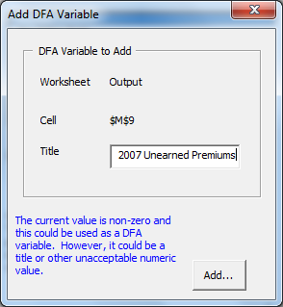
If you press the Add button, the dialog in Figure 9 will appear. You then navigate to the position in Simulation Data where the new variable is to be inserted and press OK.

Figure 9 Position and Confirm DFA Dialog
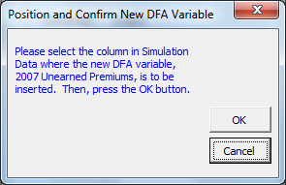

Pod Workbooks and Pod Setup Dialogs

Dynamo has been supplemented with an Excel Add-in workbook for handling clusters (“pods”) of correlated variables. This feature enables multivariate simulation for a correlated cluster of variables. An extensive discussion of random variables and how they are handed by Dynamo functions is found in

Keep Textboxes In Place
Graphs, text boxes and other “shapes” that are entered into a worksheet can become victims of worksheet row/column insertions. Their sizes will be affected by default. This utility fixes their sizes, which the use could do with Excel interface tools, but the utility is faster and does all such items throughout the workbook.

Random Variable Generation in HPC Dynamo
The type of random variable generation is set using Dynamo Model.Type of random variable generation. There are two choices: uncorrelated and correlated. If you choose the latter, there must be an associated workbook. And, there must be a relationship established for variables in the dynamo workbook constituting a pod and the setup of marginal distributions in the Dynamo. These marginal have a correlation structure that is induced using the Iman-Conover methodology. We begin with a discussion of the Pod Setup dialog. It is similar to Figure 10, but the list boxes depend on the state. In this case, the state shown is after pressing Map pod workbook button. There are three listboxes. The left-most indicates pod workbooks that are open and have been discovered when the Pod Setup dialog is opened. Typically, there would be a single workbook. The pod workbooks are separate Excel workbooks, but they must be kept in the same folder as Dynamo. When the Pod Setup dialog is opened, a pod add-in may not yet have been opened in the same instance of Excel, and the workbook list box will be empty.

Figure 10 Pod Setup Dialog after Mapping
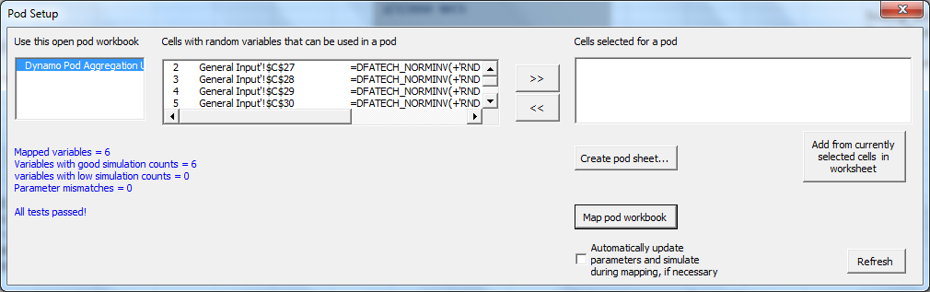
If you were to attempt to map a workbook, and this listbox is empty, the system will scan for available workbooks and present the dialog shown in Figure 11. The Close/Open status appears. By double-clicking on a pod workbook, it will be opened in Excel, and if the Pod Setup dialog also is shown, the workbook name will appear in the left-most dialog in Figure 10.

Figure 11 Pod Workbooks Dialog
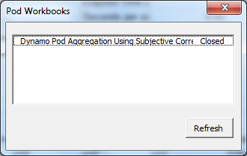

Creating a Pod
Before a pod can be created in a pod workbook, the system determines which variables in the Dynamo workbook are suitable. That is, it does a brief simulation to determine whether the parameters of the random variable inverse Excel functions are stationary among simulations. If the parameters vary from simulation to simulation, the random variables do not come from the same probability distribution and cannot be consider marginal distributions for a multivariate process. This information is what is shown in the middle listbox in Figure 10. Only these random variables are stationary and candidates for one or more pods. A digression is necessary concerning how Dynamo wraps random variable functions in order to engage in the necessary cross-talk with the pod workbook.

Random Variable Decoration
Dynamo has built in handling for several random variables: lognormal, normal and beta. These are the three inverse functions appearing in earlier versions of Dynamo. The Excel inverse functions use a random uniform variable as an argument—it is the cumulative point in the probability distribution that is returned as the function’s value. Were this uniform variable argument to be a volatile Excel function such as RAND(), every calculation would produce a new value. Further, different random variable functions could not be correlated.
A technique of decoration is used to wrap these functions. This decoration is not apt to be an activity one would often change. Rather, a pod is set up with a correlation structure and the variables for that pod are simulated in a different fashion. When a function such as NORMINV is wrapped within another function, it acquires a new name. The default decoration is “DFATech_” and it is used as a prefix on the intrinsic random variable function. For example, LOGINV() becomes DFATech_LOGINV(). There must be a macro function available name DFATech_LOGINV(). There are such functions for normal, log normal and beta distributions.
The VBA code for the decorated functions is in VBA module PodInterfacing. The original function is an argument for the wrapped function. When the decorated macro is executed, the VBA code parses the function and is able to do a variety of actions. The macro can sense a system flag indicating that native Excel random variables are to be used. If so, the decorated macro will just execute the original intrinsic function. However, there are many other tricks possible. For example, the system flag could indicate that this is a pod-mapped function. Then, the macro would obtain the multivariate value for the simulation from the pod add-in. The details of how this is done are described in the sections “Random Number Generation” and “Appliances for Correlated Random Variable Generation.” The basic mechanism is enabled by a unique random variable identifier in the original function’s uniform argument. It uniquely identifies the random variable and enables the pod mapping to work.
Variable decoration is done using a utility, Dynamo Utilities.DFATech Random Variable Decoration with choice of either decoration or no decoration. The latter is the native form of the Excel function. Random variable decoration must be in effect for pod mapping.

Choosing Pod Variables
Please refer back to Figure 10 and note the appearance of decorated random variables. You select the variables you want in a correlated multivariate structure and add them to the right-most listbox. If you double-click on a distribution-stable variable in the middle listbox, you will navigate to that cell. Conversely, the system will respond when you select in a worksheet one of the stable distribution variables. The Pod Setup dialog’s listbox will select the entry for that cell. You can see this action in Figure 12 where the selection and double click causes navigation to a directly modeled accident year value. It could be correlated with other accident periods by creation of a pod. You add this to the selected pod variables by clicking on “>>” button. If you select the cell to the right, the Pod Setup listbox will move to that next item (not shown) and it may be added to the select pod variable list.

Figure 12 Example of Pod Setup Selected Variable
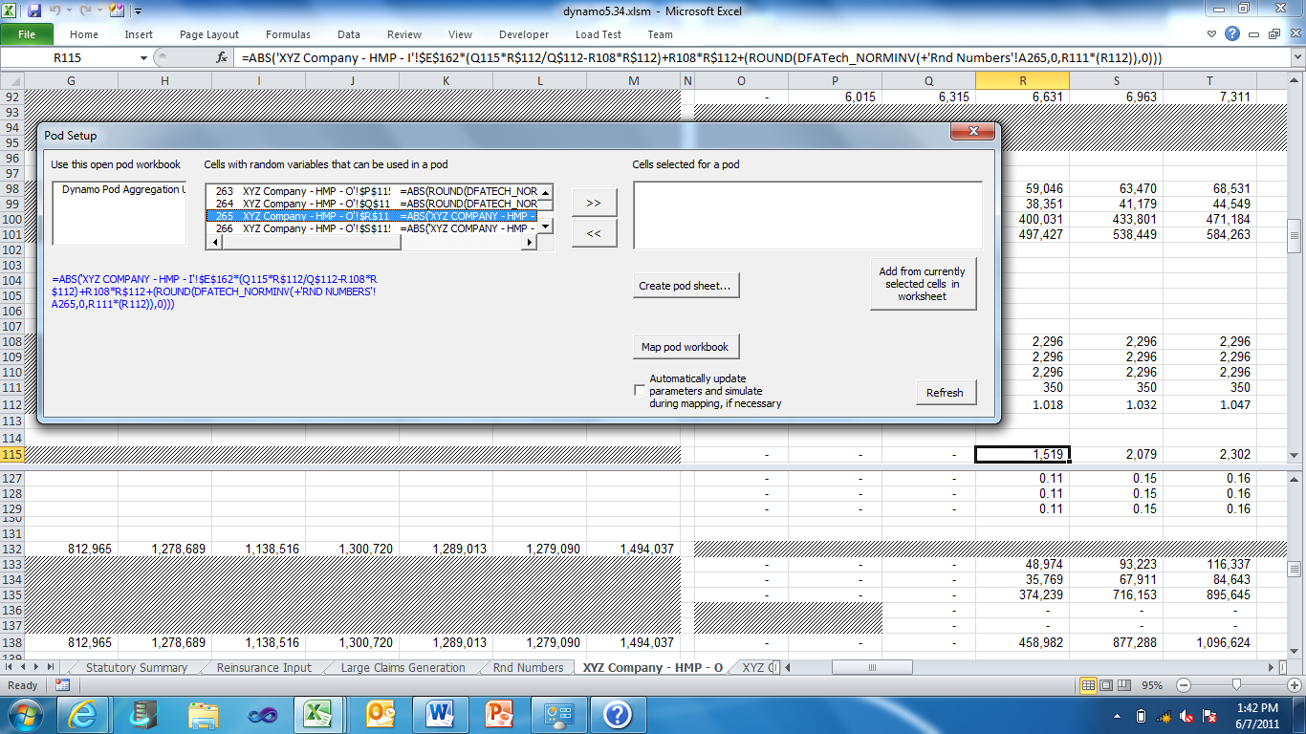
The process can be continued to add the modeled accident year variables for the line of business to a pod. The result appears in the pod setup dialog shown in Figure 13. Once the collection of correlated variables is complete, the creation of the pod and setup of the correlation structure can proceed. Please note that a pod workbook must be selected and open before pressing the Create Pod Sheet button. The construction of the pod also involves simulation of the marginal distributions according to the current value of simulation count in worksheet Simulation Data. If the current simulation count is high, the generation of the marginal variables may take a couple of minutes. There is no reason why the simulation count should be high during this pod setup activity, and you may wish to reduce it to a nominal count greater than 0.

Figure 13 Selection of Variable for a Correlated Pod
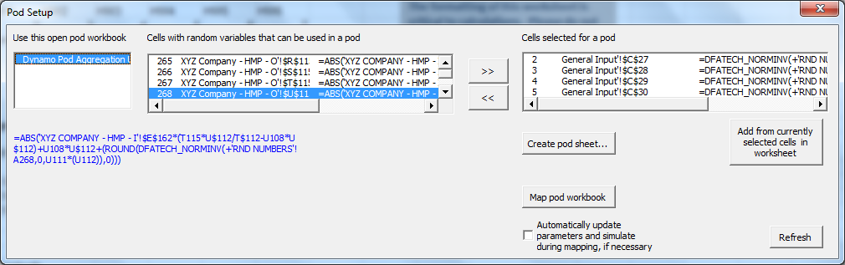
Each collection of correlated variables is represented by a worksheet in the pod add-in. When you create a pod, you will be asked for a worksheet name that is used for the pod.
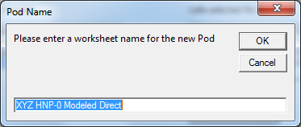
When OK is pressed, the next step is completion of a variable name sequence for the set of correlated variables. This dialog is similar to the one below. This is the naming convention used in the pod worksheet.
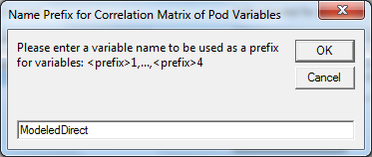
When OK is pressed after the variable name sequencing is established, control is passed to the pod add-in and the new worksheet is created. The Pod Setup dialog will provide a message similar to the one shown below
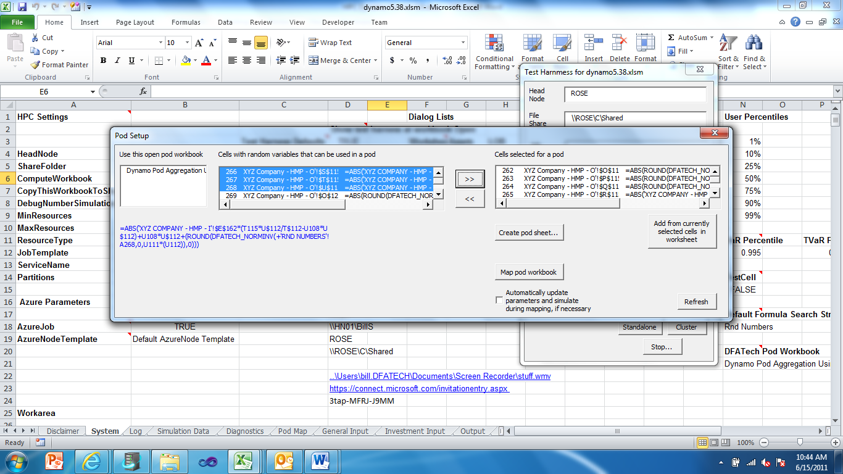
You can then use Excel navigation to move to the pod add-in workbook. Discussion of setting up the correlation matrix appears in the add-in help document. However, we present here the following table as it would appear in the new pod worksheet, and the reader will see that there is a corresponded to the variables. A portion of the simulated marginal variables is also shown under the parameters table.
Marginal Dn Parameters
Name | Model-based1 | Model-based2 | Model-based3 | Model-based4 | Model-based5 | Model-based6 | Model-based7
Reference | 262 | 263 | 264 | 265 | 266 | 267 | 268
RiskModel | NormInv | NormInv | NormInv | NormInv | NormInv | NormInv | NormInv
Param1 | 2144.344 | 2296.247 | 2312.751 | 0 | 0 | 0 | 0
Param2 | 326.8466 | 350 | 352.5156 | 356.2886 | 361.0415 | 366.5717 | 372.7303
Param3
Param4
Seed | 6165 | 9262 | 9608 | 6539 | 1216 | 2648 | 6337
System Usage
Name | Model-based1 | Model-based2 | Model-based3 | Model-based4 | Model-based5 | Model-based6 | Model-based7
Mean | 2138.329 | 2291.574 | 2315.308 | 1.50288 | 0.863222 | -4.07495 | 0.872154
Std Dev | 328.0566 | 350.182 | 353.2872 | 354.4979 | 359.1392 | 369.9293 | 370.3257
VaR | 3013.118 | 3171.791 | 3248.693 | 910.284 | 928.575 | 952.0598 | 944.5561
Capital charge | 874.7893 | 880.2166 | 933.3855 | 908.7811 | 927.7118 | 956.1348 | 943.6839
 | Marginals
 | 849.6926 | 2053.592 | 2620.353 | 59.11263 | -299.998 | -419.944 | 287.7409
 | 880.8346 | 1978.385 | 2335.414 | -0.46748 | -654.12 | -321.645 | 569.6123
 | 961.7967 | 2040.594 | 2204.876 | -836.039 | 175.5206 | -531.904 | 171.0652
 | 962.2711 | 2310.318 | 2133.717 | -591.205 | -236.284 | -213.553 | 210.3383

The variable names, reference numbers and inverse function have been inserted into the marginal distributions. In this case, the random variables constitute white noise from a standard normal whose mean is 0 and with unit standard deviation. The other parameter fields are unused. A seed is automatically generated during this pod setup operation. The seed is used to assure that the marginal distributions are replicable given the simulation count. This same property exists throughout Dynamo. Were simulation 10 to be replicated, it is guaranteed to produce the same results provided the simulation seeds are not changed.

Pod Mapping
When an association has been the pod (whose correlation structure appears in the pod add-in) and random variables in Dynamo, the map can be prepared. This is done by pressing the Map pod workbook button. This mapping can be done after a pod is setup; it must be done after they all are setup. If the mapping is successful, you will get a dialog similar to Figure 14.
When the pod is setup, parameters for the marginal distributions are passed from Dynamo into the add-in and will appear as Param1, Param2, …. That is, the distribution parameters for the correlated marginal distributions must be available for their simulation. If the user were to change the values of the parameters in Dynamo, they would necessarily have to be changed in the pod workbook. The parameters can be resynchronized by using the check box in Pod Setup, “Automatically update parameters and simulate during mapping, if necessary.” And, the pod mapping then would assure that parameters are synchronized between Dynamo and the pod add-in. However, it is easy to forget using Pod Setup for this synchronization purpose. Reliance on this being done could be a mistake—it is easily forgotten. So, at runtime there is forced parameter synchronization, simulation of marginal distributions and induction of correlation using the Iman-Conover method. Unfortunately, this may be unnecessary when there are both sufficient marginal distribution simulations done with the correct parameters. The check box in Pod Setup is used during pod mapping primarily for inspection purposes were the user to want to do any cross checking or verification of the process.

Figure 14 Confirmation of Pod Mapping.
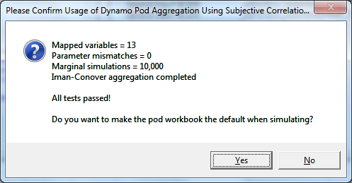

Random Number Generation
One of the hallmarks of Dynamo since its inception is the clever use of indirect addressing for uniform random numbers that are used in connection with Excel intrinsic, inverse functions. For example, the intrinsic function LOGINV is widely used for generating a lognormal random variable. The inverse function is evaluated based on a uniform variate ranging between 0 and 1. The use of the Excel intrinsic function, RAND(), fails because any simulation is not replicable. Further, because it is a volatile function, RAND() will always recalculate whenever a worksheet is recalculated. Model design, debugging and auditing is impossible when the values of dependent cells are changed because a volatile variable such as RAND() has changed during a calculation. The original designers of Dynamo used a clever trick of indirect addressing for uniform random numbers. Each inverse function replaces the RAND() argument with a reference to a uniquely addressed cell in a worksheet, “Rnd Numbers.” The actual generation of uniform random numbers then can be exogenously controlled and recalculated only when the user wants to. Further, this indirect addressing enables the list of uniform numbers to be seeded and replicable.
For example, suppose a run is seeded to the integer 12345. The sequence of random numbers can be entered using this seed and each subsequent call to the VBA function RND() will return a replicable sequence when that seed is used again. The seed and simulation number can be combined to produce a sequence of uniform numbers that are unique to the simulation. The job can be initially seeded. If there are N trials, the first N uniform numbers may be used to begin a replicable sequence for each trial by simply traverse the job-seeded uniform number until reaching to i^{th} uniform variate which is taken as the first uniform variate for the i^{th} simulation. Then, if the simulation requires M uniform random numbers, they are taken as the forthcoming M sequence of uniform variates.

HPC Dynamo Uses Variable Decoration to Redefine Random Numbers
This topic is reviewed in detail later (See: The Importance of Random Variable Decoration). But it is worth mentioning now because it greatly alters the way Excel intrinsic functions operate by providing great flexibility for deviation. The concept of decoration means that an inverse function such as Excel’s NormInv is wrapped within another function. Because NormInv has a uniform random number as an argument, the function decoration and wrapping serves to call a different function before the Excel intrinsic function is evaluated. This provides the programmer with an opportunity to return something other than the inverse value that otherwise would be calculated by Excel. This is a good time for the reader to use one of HPC Dynamo’s dialogs to look at the random numbers. Right-click and choose Dynamo Dialogs.Search Formulas for Substring. This dialog defaults the search string to “Rnd Numbers.” This is worksheet name that is part of the full range reference to a location in worksheet “Rnd Numbers.” For example, if you double click an item selected in Figure 15, you will navigate to that cell and can examine the formula. In this case, the random variable decoration, DFATech_, is in effect.
Figure 15 Formula String Search Dialog Showing Decoration
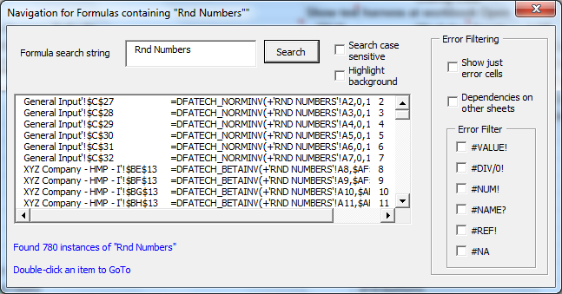
The full formula is:
=DFATech_NORMINV(+'Rnd Numbers'!A3,0,1)
Notice that were the decoration removed, the formula would be more familiar:
NORMINV(+'Rnd Numbers'!A3,0,1)
The first argument of NormInv is “Rnd Numbers”!A3. The other two are the mean and standard deviation. This formula has a dependency on a uniform random variable in worksheet “Rnd Numbers.” So, whenever that range is changed, the dependency will cause the NormInv function to fire. And, this occurs regardless of whether that function is wrapped in another one. But, when it is wrapped, as in this case with DFATech_NORMINV, the function call is not made to Excel’s intrinsic function it is made to a user-defined macro called “DFATech_NORMINV()”
Decoration provides a convenient method for returning something other than the indicated inverse normal value whenever the uniform number is updated. For example, the user-defined function (UDF) could determine that this variable is one of a pod of variables that are correlated and it must extract a random variable that is related to a multi-variate simulation. Alternatively, there could be a flag that tells the UDF to return the mean or median of the distribution. This also would require additional code in the UDF, but the reader can sense that decoration of functions (and thereby converting them into UDFs that are defined in VBA code) can enable useful programmatic tricks.
It is easy to decorate or undecorated using the right-click Dynamo Utilities.Random Variable Function Decoration.Remove DFATech_ Decoration. When that is done, the result can be seen in Figure 16 where the Excel intrinsic function can be seen. In this case, a change in the dependent uniform random number argument will fire the Excel inverse function and return an inverse value.
Figure 16 Formula String Search Dialog Showing Decoration
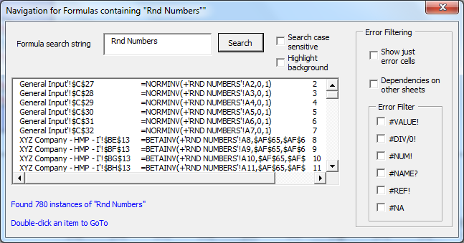
The mode of random variable operation is important to keep in mind as the results of a simulation can be greatly affected.

Formulas Resulting in #DIV/0!
There was a widespread problem in Dynamo; it is a division formula involving undefined cells in both the numerator and denominator. If a cell contains the formula =A1/B1 and both cells are blank, the result is #DIV/0! Such a formula may be nonsensical, but it is not an uncommon occurrence when data does not exist for cell A1. Unfortunately, dependences can arise when a collection of items is summed, but really some of the components don’t exist. The vacuous components that, nevertheless, show as #DIV! errors can have unintended and important consequences. A sum is thought to be an error when, in fact, it is not and error. Then, this error condition propagates from the sum (which is unintentionally #DIV!—really containing valid and missing components) to other exhibits. In fact, the error condition in the sum is a spurious condition. Arguably, there are times when 0/0 really should not be thought of as division by zero; rather the result should be either NULL or 0. Conditional logic in cells can catch this type of thing, but it is a nuisance to deal with.
An example of this phenomenon was the ramifications on the bond summary exhibit.

Table 1 Propagation of #DIV0! Errors
XYZ Company - Summary of Bond Accounts (000)
 | 1st | 2nd | 3rd | 4th | 5th
 | Year | Year | Year | Year | Year
Description | 2008 | 2009 | 2010 | 2011 | 2012
Total Beginning BV | 30000 | 31780 | 34001 | 37346 | 40005
Total Beginning MV | 31800 | 32062 | 34017 | 37073 | 39941
Accumulation/(Amortization) | - | #DIV/0! | #DIV/0! | #DIV/0! | #DIV/0!
Reduced BV | 15000 | #DIV/0! | #DIV/0! | #DIV/0! | #DIV/0!
Increased Investment | 16780 | 14201 | 13636 | 12720 | 13428
Change in BV | 1780 | #DIV/0! | #DIV/0! | #DIV/0! | #DIV/0!
Total Ending BV | 31780 | 34001 | 37346 | 40005 | 43174
Total Ending MV | 32062 | 34017 | 37073 | 39941 | 43157

There are SUM formulas on which items in the table are dependent.
We used the Formula Navigation tool to identify formulae containing the string “SUM” and looked for those formulas that indicated #DIV0! Values and had dependencies on other sheets. A VBA function was written (SUMErr) that can be substituted for the SUM function. It determines whether the items being summed contain an error value, and if so, the error terms are ignored. Were all items to be errors, the function returns zero. There is, of course, an occasion where this filtering for errors may not be desirable, but in this case it improves summary exhibits such as Bond Summary.

Figure 17 Using Formula Navigation Dialog to Track SUM Formulae with #DIV0 Values
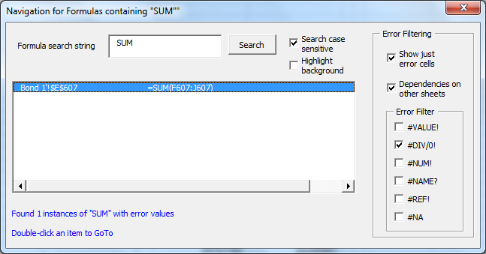

Statistics
Dynamo has always had a statistics section. It was designed to have worksheet intrinsic functions such as AVERAGE, STDEV, and PERCENTILE working on preset (and generally over-specified) cell ranges. Many of the Excel intrinsic functions will ignore blank spaces, and this approach worked well when the statistics were intrinsic functions. This approach still can be used because during a simulation, the DFA variable simulations are given range names that coincide with the variable title. They are decorated with the prefix, “DFATech,” and blanks in the name are replaced with the underscore character (“_”). So, cell formulae easily can be written using these names. For example, =MyStatistic(simPHS_2012) would run VBA macro code using the last simulation and results for the variable named “PHS 2012” in worksheet Simulation Data. Please note that the ranges include only the cells created during the last simulation—the range is dynamically altered to include only cells inclusive of the number of simulations.

CreateStatisticsTable
This is a VBA procedure in the Main module of the Dynamo workbook. It is responsible for creation of the section in worksheet Simulation Data called “Simulation Statistics.” Statistics in this section now are computed “on-the-fly.” The Statistics section does not contain formulas—only value cells that are written by the CreateStatisticsTable procedure. The reason for this change was primarily because its rank is determined entirely by the number of DFA variables which change grow or shrink. Further, there have been many statistics added and fiddling with specified formulas and various macro function names was averted. There now is a convenient dialog that may be used to specify various statistics appearing in this table for any given DFA variable. Some of them require knowledge of the tail-of-interest which is specified either with a + or – reference.

Value at Risk (VaR), Tail VaR and Expected Policyholder Deficit
These statistics have been added to Dynamo and may be calculated for any DFA variable. The inclusion of any of them in the Statistics Table is handled by a string variable in Output Setup.

Graphics
HPC Dynamo has a revised graphics package. There no longer is a query line in the Simulation Data worksheet asking for a graph (“Yes/No”). Now, the use selects a data point anywhere in a column to be graphed and uses right-click menus to create a graph similar to Figure 18.

Figure 18 Example of a Dynamo Graphic for a DFA Variable

A graph can be rendered for any column of data anywhere in the workbook that meets certain requirements:
- The column must contain only numbers and have a title at the top.
- The graphics likely would be created primarily in the DFA simulation data worksheet. If a an existing graph for the column appears in this workbook and that column is (re)graphed, the graphic will be updates. If the user wishes to preserve the original graph, it must be cut and pasted into a different worksheet.
- The data for a graph are collected in a system worksheet named “Graphics.” The formatting of this worksheet is under system control, and it should not be modified or used for other purposes.

Graphics Cleanup
It is easy to get workbook clutter with graphs. There is a button in the Graphics worksheet and a comparable Utilities.Clear All Graphs… menu item for removing graphs. This cleanup will attempt to find and remove any graphs in the workbook for which there are associated data in in Graphics worksheet. This cleanup will remove all gr

Reserved Words, System Worksheets and Restricted Ranges
The HPC Dynamo version has many items warranting user attention. There are variable name decorations (prefixes) that must not be used by the user. Undesirable consequences such as deletion of user-specified variables having the name decoration could result in their deletion.

Reserved Words and Variable Name Decorations
Reserved (case-insensitive) | Description
sim_ | This is a decoration applied to simulation variable names and used as the range name for the simulation results of that variable.
DFATech_ | This decoration is reserved for random variables that are used in connection with a DFATechnologies, LLC Add-In workbook used for multivariate simulation.

System Worksheets and Titling Conventions
As a general rule, users should not modify system worksheets either by inserting or deleting columns or rows. Similarly, cells should not be moved around. The programming often uses <range>.CurrentRegion to obtain a block reference to an array whose shape may change. Because of this, the user will often find titling in system worksheets to be two rows about the relevant range name rather than directly above. In this way, titling is not included in the block when .CurrentRegion is used, and the title is preserved when such a range is cleared.
System workbooks is a category of worksheets that is included in the listing of Dynamo worksheet types.

DFA Variable Names
These names are assigned by users in worksheet Simulation Data. They are used both for titling purposes and in range name references that are used during simulation. These names should contain neither special nor unusual characters that would be prohibited in range names (for example, no arithmetic operators may be used such as “/”). They also are used in exhibit titles (without decoration or substitution of blank characters).

Hot-Key Navigation
In addition to navigation dialogs such as Worksheet Navigator, there are some hot-keys that may be used too.
Hot Key | Purpose and Usage
Ctrtl-Shift-R | This is a macro that resets various global variables. It also can be triggered from a button in the System worksheet. It is used primarily when there is a crash in the operation of some system function or as a result of using the Esc key and then confirming cessation of the program. However, it is also when VBA work causes loss of global variable values; this always will occur during ansignature change of a VBA procedure. When a crash occurs, the global VBA variables are reset causing a loss of expected functionality. The global reset operation reformulates these variables and certain system functionality.
Double-click action in worksheet Simulation Data | There are DFA variables in this worksheet for which simulated probability distributions are developed during a run. You may double click anywhere in a variable column, and you will be given an opportunity to go to the cell of the referenced variable. The system determines where this is based on information in the Output Setup area.

Running a Model and Working on a Model
The cellular logic of a model involves setting up lines of business, accounting overlays, such as Statutory or GAAP, and determining what output is dependent on this cellular logic. That is, one “makes” the model or one “runs” the model in a simulation mode.
The “output” is a set of DFA variables that are defined (or reference) these output cells. Dynamo can capture any cell throughout the workbook as a DFA variable. A probability distribution is built up during the course of a simulation by tabulating the values of the output cells as they change across simulations.
With the inclusion of random variable decoration, some new alternatives open for facilitating the first role—model building. A right-click menu item has been added for “deterministic setup.” The choices include setting random variables to their means, median or other specified percentile. This is deterministic in the sense that once done, work commences on the model without doing a simulation.

Adding New Lines of Business
New lines of business can be easily added to Dynamo, but there are important implications for the DFA accounting overlays throughout the model and getting results of the new lobs properly aligned in various SUM() formulas. Please see section ”Setting Up New Lines of Business “ where the topic of 3D variables is covered in depth.

Output Setup
The ultimate output of a Dynamo simulation is the empirical distributions for DFA variables. These appear in worksheet Simulation Data in a section entitled “Output Setup.” The entries in this range area should be made using the Dynamo dialog for Add DFA Variable. However, insertion can be done manually as well if you know the reference for the DFA variable. It is safe to insert a column in the setup area.

Figure 19 DFA Variable Setup
Simulation Parameters
Specific simulation # | 100
Random number seed (0-10,000) | 1011
Number of simulations | 100
Output Setup
Sheet Name |  | Statutory Summary | Statutory Summary | Statutory Summary
Cell |  | l12 | m12 | n12
Reference |  | 'Statutory Summary'!l12 | 'Statutory Summary'!m12 | 'Statutory Summary'!n12
Title |  | PHS 2008 | PHS 2009 | PHS 2010
Statistics |  | -epd;-tvar;+var | -TVAR;epd
Simulation Statistics |  | PHS 2008 | PHS 2009 | PHS 2010
Mean |  | 17,821.328 | 18,291.762 | 19,037.669
Growth in Mean |  |  | .026 | .041
Standard Deviation |  | 989.228 | 1,608.707 | 2,251.684

Systems Setup
There are many cells throughout the workbook for setting system parameters. These affect the operation in one way or another. Typically, there is a title and cell comment associated with these parameters. Please note that Table 2 is not an exhaustive listing. But, it highlights some of the most important system parameters that are spread throughout system worksheets. These worksheets contrast with what are user worksheets that largely specify line of business, accounting overlays and other modeling actions, all of which are not generally affected by system oriented worksheets.

Table 2 System Parameters

Parameter | Location | Description
 | System | This is a collection of cells the control HPC. There are two adjacent columns. The user-formulated setting should be in the right column labeled “Test Harness Settings.” These are the defaults that appear in the test harness dialog. The items are specific to the HPC environment of the user. The Head Node is the name of the computer where the HPC head node is located that is used for job scheduling. The Share Folder must be accessible to all compute nodes on the HPC cluster. This is a full path for the folder.  Compute Workbook is a name that is used when the Dynamo workbook is copied to the file share folder by the system.  CopyThisWorkbookToShare would typically be TRUE. Only if the workbook is in a static condition and already is on the file share should this be FALSE.  Min/Max resources will limit the number of resources used by HPC.  ResourceType is an important setting. In general, the choice should be nodes or cores. The former will result in a single instance of Excel on an HPC computer regardless of the number of cores on a computer. Core allocation likely will result in multiple instances of Excel being opened on any compute node. In general, Dynamo has intense compute requirements that are well-handled by core resource settings. However, some experimentation between core/node settings may provide useful. The author has experienced improved cluster performance with node settings when the simulation count is low.  Partitions is synonymous with simulation count.  Azure parameters relate to the use of Azure for supplementing compute nodes with Azure nodes. There is an HPC template associated with the use of Azure nodes for Excel SOA applications such as Dynamo. The name of the Azure Node template must be provided. In addition, when this field is non-blank, the behavior of the job launched is modified. The workbook (and DFATech pod workbook if multivariate simulation is being done) will be packaged and uploaded to Azure. This is optional, and is only necessary when the workbook(s) have changed.
  HeadNode
  ShareFolder
  ComputeWorkbook
  CopyThisWorkbookToShare
  DebugNumberSimulations
  MinResources
  MaxResources
  ResourceType
  JobTemplate
  ServiceName
  Partitions
  Azure Parameters
  AzureJob
  AzureNodeTemplate
Dialog Lists | System | This is a set of ranges that control the operation of the Worksheet Navigator. Please note that the leftmost column is categories and there must be an associated column to the right that contains the entries for that category. Further, each category column requires a range name that is identical to the category name.  The table is not updated by the system. If the user adds worksheets, they can be entered into the appropriate columns, and categories can be expanded if desired.
User Percentiles and related nearby ranges for VaR, TVar settings | System | These determine the output that will appear in the Simulation Statistics (worksheet Simulation Data).
 | Simulation Data | These are very important cells, particularly Number of simulations. This entry determines the simulation count when the model is run without the use of the Test Harness dialog.
  Specific simulation #
  Random number seed (0-10,000)
  Number of simulations
 | Simulation Data | Random numbers generated is related to the overall number of random variables. It can, and probably should be over specified. Dynamo 5.0 has 580 random variable cells. This field is set to 850, which clearly overstates the needed uniform variables that must be generated. Another way of looking at this is that the user could enter many new random variables before the field requires change. However, it is relatively easy to increase demands for (uniform) random variable count when new lines of business are added to the model. So, users should be aware that this number may require modification.  Graph bin count is used to determine the number of intervals that appear on frequency graphs of DFA variables.  Uncorrelated, InLine random variables is a TRUE/FALSE boolean of importance. When it is TRUE, an attempt will be made to use a DFATech pod workbook for multivariate simulation. This means that all random variables should be decorated. Otherwise, the simulation will use a uniform random variable as the argument of the inverse functions uses for variates regardless of whether they have been decorated.  Stationary parameter test trials for random variables refers to the number of simulations that are used in Pod Setup for determining parameter stationarity. In general, not a large number of trials is required to ascertain whether the parameter arguments are, in fact, invariant. As few as 5 trials is typically sufficient.  HPC show diagnostics is a boolean that ordinarily should be FALSE. When it is TRUE, the system will generate information about the performance of HPC_Execute for every simulation. This is a field used by developers to assist in measuring HPC performance.  Drain interval relates to how often a block of accumulated simulations will be written to Simulation Output. This should be at least 100-2,500, depending on simulation volume. Otherwise, cluster performance may be impaired and out-of-memory errors will occur.  When the drain interval is set to 100, there will be an accumulation of 100 simulations results stored in memory before they will be drained and moved to the simulation output area. During the accumulation interval, the availability of the client is not impeded, and HPC can deliver results faster to HPC_Merge. This improves performance. However, if the drain interval is too large there is an excess memory demand put on the system. In general, the larger the number of simulations, the larger should be the drain interval setting. A value of 1,000-2,500, should work well for simulation counts between 500K to 750K if the client computer is fast.
  Watch counter
  Random numbers generated
  Simulation data version
  Graph bin count
  Uncorrelated, InLine Random Variables
  Stationary parameter test trials for random variables
  HPC show diagnostics
  DrainInterval
Help Resources | System | Help Documents, Video Clips, Links are listed, respectively, in three columns.

Run Setup
Dynamo may be run in several modes:
- HPC standalone. This emulates HPC callbacks to VBA HPC_xxx procedures, but it is done entirely on the client machine. The HPC cluster is not used. All of the HPC_xxx procedures are called and run on the client instance of the workbook. HPC Dynamo.Run
- HPC cluster. This launches a job on the cluster. There are VBA procedures open the cluster session. The HPC_Execute procedure is run on cluster instances of the Excel workbook. Other HPC_xxx are done as callbacks on the client computer. HPC Dynamo.Run
- Original model simulation mode (a menu item called “Run simulation.” There is no use made of HPC_xxx VB A procedures. This is the modality that must be used when an HPC cluster is not available. All work is done on the client computer. Dynamo Model.Run simuilation
In addition, there is a test harness shown in Figure 20 that may be used for rapid launch of HPC jobs; it bypasses other setup that may be less convenient because it would require adjustment of values in different workbook cells. Notice that the number of trials (partitions) can be set in this dialog.

Figure 20 Test Harness Dialog for HPC Run Launch
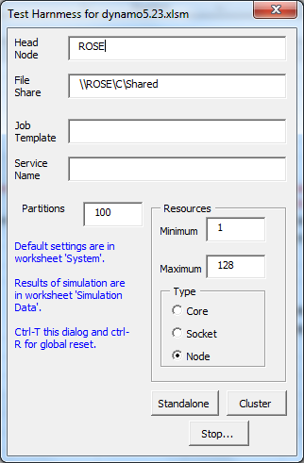

The Importance of Random Variable Decoration
Before we venture too far into the various run setup modalities, a review of variable decoration is required because the use of decoration greatly impacts the type of random variables that are obtained. The decoration of inverse functions throughout the model results in Excel calling a user-defined function (UDF) instead of the navtive function. For example, were the function NORMINV(.55921,0,1) to be evaluated, the cumulative point of the {0,1} normal at .55921 would be returned by the function. However, when the function is decorated, a UDF is called. And, the programmer has great flexibility in how to design what is actually returned by the UDF. Of course, were the function to be decorated as DFATech_ NORMINV(.55921,0,1), there must be a function within VBA code called DFATech_ NORMINV. Notice that it would receive the same three arguments. There could be global variables that are set that trigger conditional logic within the DFATech_NORMINV UDF.
One condition could be to, say, return the median value of the NORMINV. If so, the UDF would substitute .5 for .55921 and evaluate NORMINV(.5,0,1) and return that inverse value as the UDF result. Of course, a simulation of more than a single trial would become meaningless—all trials would produce the exact same results during the workbook calculation. On the other hand, this setting of all the random variables could be convenient for other purposes such as model modification where cells that ultimately depend on the random number cells are changed but the user doesn’t want recalculation to produce new values. Rather, the modeler is interested in using mean or median values of the random number generators for the purpose of model change being evaluated (a) using central tendencies of the random variables, and (b) without the model capriciously changing the values of random numbers whenever the F9 (calculate) key is pressed.
There is functionality for presetting random variables to their central tendencies or simple to turnoff further change in the current values. However, this only can be done with decorated random variables. The basic approach of variate generation in Dynamo has not be changed so much as it has become more controlled.
In addition, the use of multivariate simulation is completely dependent on the use of decoration. In this case, the UDF function that evaluates the decoration has an opportunity to determine whether the particular variable is a member of a correlated pod. It than can ascertain the pod’s n-th simulation (which was setup prior to Dynamo beginning it’s own simulation) and return the multivariate value. The same process unfolds for other variables within the pod so that the random variables used by the pod members in the n-th simulation are correlated.

Original Model Simulation Mode
This mode will run simulations. It relies on simulation count being entered into setup cells in worksheet Simulation Data. The count will be the number of trials during the next run, and these trials may be added to previous trials already in the Simulation Output section of this worksheet.

Setup Deterministic Workbook
This right-click menu item to enables you to fix all decorated inverse functions such as NormInv to their means, medians or a specified percentile.

Using Dynamo in Microsoft HPC Clusters
There are several systems parameters relating to HPC setup. These were introduced in Figure 20 when the test harness was illustrated. An Excel HPC run requires specification of the computer with the head node, the file share that is available to all computers in the HPC cluster, and resource allocation method

Head Node and HPC File Share
These fields in the System worksheet require some knowledge of the HPC cluster that is being used. Dynamo has been written for a local HPC cluster (possibly augmented with compute nodes in Azure) , and one will need to know the name of the computer on which the HPC head node is located for the cluster operation of Dynano. In addition, a cluster file share or folder is specified, and the full path for that folder must be given. This is a file share that can be seen by all HPC computers operating in connection with the head node.

HPC Resource Specification
The choice between cores and nodes is likely to be critical to performance. The author has generally found core resource allocation to be significantly faster. The difference lies in the number of instances that will operate on any given computer within the cluster. It is not uncommon for computation machine to have 4 or more cores. When HPC senses multiple cores and the allocation is by cores, then it will open multiple instances of Excel on the same computer and manage them so that each core-instance of Excel operates as a separate compute server. That is, each instance will receive HPC_Execute callbacks. Conceptually, if there were 8 cores the client is interacting with eight computers. However, with a node resource allocation, only a single instance of Excel is opened on any HPC computer regardless of the number of cores.

High-volume HPC Simulation Tuning
HPC Dynamo cannot easily process the rapid-fire receipt of data from compute nodes without resorting to tricks. This is particularly true with core allocations and operation within a large HPC cluster. The approach that finally was found acceptable involves the use of disk storage. Batches of data are stored in a memory sink as they are received in HPC_Merge. The sink size is specified in worksheet Simulation Data and is referred to as the “drain interval.” It might be, say, 1,000 simulations. When a batch of this size has been received, the memory stash is drained to hard disk. This involves conversion to text and writing to a file. There is latency associated with the operation, but it does not appear to be severe when the client computer is fast.
When the last simulation is received, the memory sink is given a final drain, and the HPC session is disposed. At that point, the text file is read, results are populated into the Dynamo workbook and statistics are prepared.
The motivation for this approach lies in cluster starvation which is a situation when the client computer cannot operate fast enough during either of two callbacks: HPC_Partition and HPC_Merge. The manifestation of starvation appears in two consecutive forms. First, Excel will throw a memory error dialog indicating that other applications need to be closes. This soon follows with an HPC error involving failure of the client to operate fast enough.
The method currently used in Dynamo has been tested with runs for 1 million simulations on an HPC cluster with over 200 cores.

Using HPC Cluster Manager
The Cluster Manager utility is installed with HPC Pack, which is a requirement for any computer that is part of the cluster operation. So, the user of Dynamo likely will have access to this utility. The topic is beyond the scope of this help guide. However, an initial monitoring of cluster nodes is desirable before starting an HPC job. Please note the Node Management view and Heap Map shown in Figure 21. Each box is a snapshot of CPU activity on a node. It is similar to examining processor activity using a computers Task Manager utility. It is possible for a node to be shown as in a healthy state (not shown in the figure), yet a box to appear in the heat map with an X through it and no indicated percentage activity. This problem appears to cause node failure. There can be allocation of tasks to the X node, but failure of that node to complete execution; the client does not receive HPC_Merge callbacks, and the job is hung at an advance state of execution.
The Cluster Manager Job Management view (shown in Figure 22) provides Active and Finished job details. Right-click on “Progress,” and you will obtain popup menu options both for job cancellation and job details (see Figure 23 which show the session progress, but has tabs at the left for other detail, including allocated nodes and job details.)

Figure 21 HPC Cluster Manager
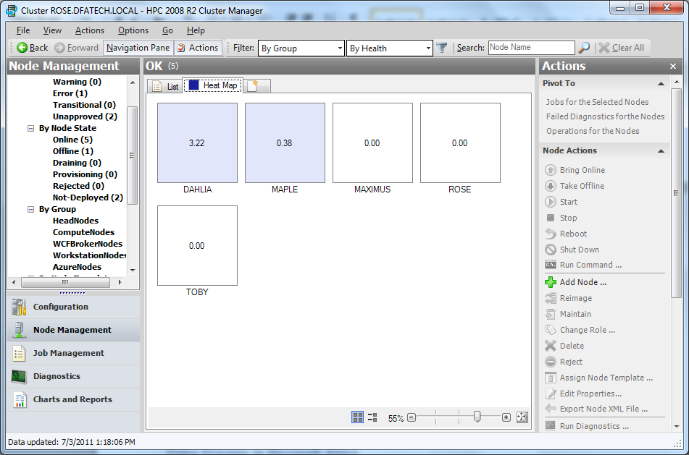
Figure 22 shows a job that was at an advanced state of completion (99%) and then cancelled. (Dynamo HPC.Stop… also could be used to cancel a running HPC job.)

Recovery of Simulations from a Drained State
It is possible to run code that ordinarily would have run at job finalization but which failed to run because a job hung. This is done using a Dynamo utility Utiliites.DrainRecovery…. This will move completed simulations from the drain file into the Simulation Output.

Figure 22 Cluster Manager Showing Job Management View
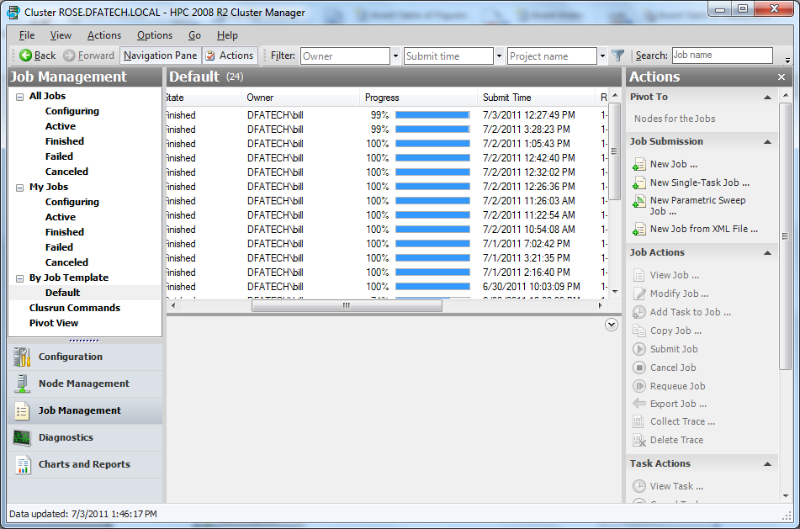

Figure 23 Cluster Manager Job Details
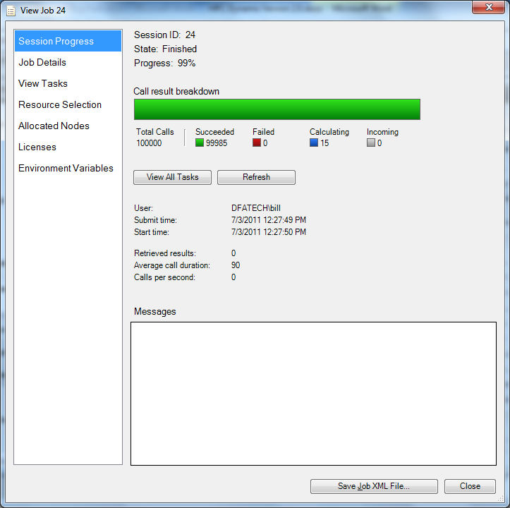
HERE!!! Need to give some performance stats for running on the MSFT cluster

Using Dynamo in Microsoft Azure
HPC Dynamo has been tuned to allow the use of Azure VM nodes. This is a feature that became available in HPC Excel with the release of Service Pack 2 of HPC Pack. The setup of Azure compute nodes is beyond the scope of this help guide. However, it is an important feature because Azure enables the use of Dynamo in burst capacity for very high volume simulations when the local HPC cluster may be small. That is, Azure can supplement an actuarial HPC cluster for both testing and production level activities.
If you want to use Azure, there are system cells in worksheet System that are affected. Please refer to Figure 21. The name of the Azure node template must be indicated as well as a boolean that will be used by the system during an HPC run.

Figure 21 Setup for Azure Operation
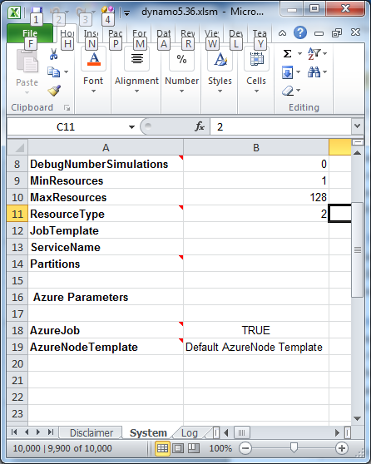
When Azure is being used, Dynamo will present the dialog shown in Figure 22. There are several actions associated with this that can, in total, be time consuming. “No” would be an appropriate response when you are sure that Azure already has been provisioned with the operative version of the Dynamo workbook during a prior upload. “No” is appropriate because you will save runtime. Note that when a pod workbook is being used, it too must be a recent version. Otherwise, an out-of-date pod workbook will be used in Azure. When either workbook is out-of-date, you must do an Azure upload.
So, “Yes” is warranted in many circumstances when the model has been changed. When a revised version of Dynamo has been locally saved, it has not been “saved” to Azure; any prior version persists there. There are several actions that occur when an affirmative response is given in the Figure 22 dialog, and it is important for the reader to understand the actions involved.
First, the workbook is copied and an automatic shrink is done to remove the possibility of bloat. Second, the workbook is uploaded to Azure. This operation usually will occur under five minutes, which is the default timeout for such uploads. Because the “ShrinkIt” is automatic, it is important to assure that the position of the “ShrinkToHere” cell position is correct. Please see section:” ShrinkToHere—Solve Workbook Bloat Problems!”

Figure 22 Upload Package to Azure
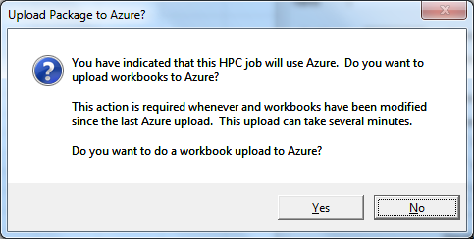
Azure is a very broad topic and largely beyond the scope of this help guide. Azure compute nodes for HPC Excel require an Azure subscription. Once this has been obtained, a local instance of a fully configured and operating virtual machine (VM) can be used as the basis for virtual hard drive upload to Azure. The experience is not for the faint of heart. There are issues such as security certificates, operating system as well as the provisioning of the Azure nodes. Also, an Azure template must be set up using the HPC Cluster Manager. This, again, is not for the faint of heart. Azure has on-going management needs such as Azure node starting and stopping in order to manage the billing associated with Azure operation.
More information can be found at www.microsoft.azure.com. Once this preliminary setup is complete, one will find at this azure portal a wide variety of tools. Ultimately, you will end up with deployment on Azure and something similar to Figure 23.

Figure 23 Azure Deployment Health on the Azure Portal
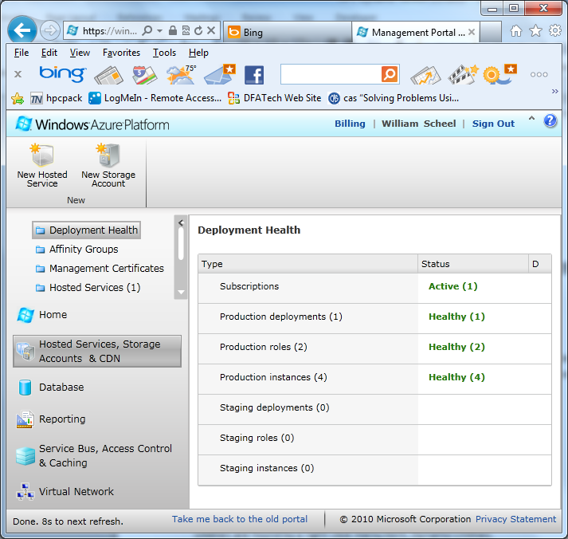

Setting Up New Lines of Business

Introduction
Dynamo is organized with each line of business (lob) comprising two comprising two related worksheets. The naming convention is <lob name> - <{O,I}. This naming convention is not required, but were a user to want a new lob, it is easily set up by copying and existing pair worksheets and then renaiming them with a new <lob name>, However, there are several caveats when doing this:
- The worksheet structure for the lob is copied. So, the model operation for the new lob is identical to the old one unless either worksheet in the O-I pair is revised. An identical pair may be desired if the purpose is to induce another lob but retain the actuarial methods. On the other hand, the pair may serve as a useful start for lob model revisions.
- There are 3D references that encompass one or more of the pairs. This 3D reference will be critical to the proper accounting for the lob. This topic is reviewed in a following section. However, the placement of a new lob within existing lobs is critical in order for the new lob items to be included in the accounting framework.
- It is easy to find 3D references using the Search Formulas for SubString dialog. There also is an unexposed macro in Dynamo named, “ThreeD” within module DFATechUtilities that will search for and list 3D formulas throughout the workbook.

Note on 3D References
Dynamo uses 3D references in functions such as SUM(). This is an example:
=SUM('XYZ Company - HMP - O:XYZ Company - WC - O'!O30)
This type of reference has a cell range specification and a range of worksheets for which the function action is performed. In the above example, all worksheets between the left and right worksheet specification are added. It is important to note that these worksheets must be contiguous within the workbook. Of course, spurious workbooks must not be positioned in between because their cells would be included too.
The above expression illustrates the importance of how you position a new lob within existing ones. The layout of lob worksheets within Dynamo is to place all of the “I” in a contiguous worksheet block and all of the other “O” lob worksheets in another block. Were the user to induce a new lob, it’s “O” worksheets should be placed within the span illustrated in the above cell formula.

Utilities
Utilities are found by a right-click menu item, Dynamo Utilities.

ShrinkToHere—Solve Workbook Bloat Problems!
A frequent Excel nightmare is workbook bloat. When a workbook is saved with a large amount of new data, the size of the saved file increases. When the data are cleared that created that extra volume and the workbook is saved again, the file size may not decrease as expected. The cause of this bloat is not understood by the author. But, the often is a way to judge where the problem is occurring. Excel has a special cells range method with an argument, xlCellTypeLastCell—the last cell in the worksheet. You can observe this position in any worksheet by typing ctrl-End. When a workbook becomes bloated, one will usually find one or more worksheets where the end cell is further to the lower right than need be.
The end position moves whenever data populate into rows or columns that have been unused. This, of course, will occur when simulation count is large. With HPC it is possible to rapidly simulation tens of thousands of trials, and they will increase the usage space of worksheet Simulation Data (and others). If the worksheet is subsequently saved, the file size will grow, and a bloat condition may arise even if those simulation data subsequently are erased. The largest row/column cell determines this end point. Bloat can be removed, often dramatically so, by repositioning this end point so that unused rows and columns are removed. Unfortunately, this only can be done by the creation of a new worksheet and copying the contents of the bloated worksheet from cell A1 to wherever the true end cell should be. We refer to that desired end position as the range ShrinkToHere.

Figure 24 ShrinkToHere Dialog
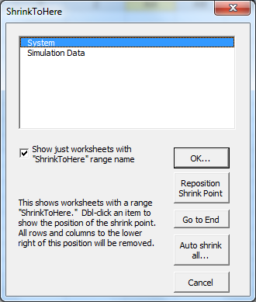
There is a check box in Figure 24 that will allow you to toggle between a list of just those worksheets already having the ShrinkToHere cell or a list of all workbooks. You can add this cell name to any worksheet by first selecting the worksheet in the list box. That worksheet will be activated and you can select the “virtual” last cell. This selection must be done carefully because all columns and rows to the right and below that cell will be removed when you perform a shrink operation.
This cell position is not monitored. Were you to have new rows or columns extend beyond that point, the existing location of the ShrinkToHere cell does not change. A reminder of this occurs when you select a worksheet and press the OK button, so you can cancel the shrink if you remember that the virtual end cell requires adjustment.
The ShrinkToHere utility can be useful when you observe a bloat condition. Please note that clearing cells and then saving should result in a reduction in workbook file size. There is a complex interaction of repeated file saving, macro programming and possibly other events that appears to cause bloat. Once that condition arises and cell clearing does not significantly reduce file size, it is time to try the ShrinkToHere utility.

Auto Shrink All
This button works only on worksheets already containing the ShrinkToHere range cell. But, it does the shrink on all such worksheets. The OK button only works for the selected worksheet. Please note that the workbook is modified in place and not saved. However, prior to doing any shrink operation, one should have backed up the workbook.

Keep Textboxes In Place
Graphs, text boxes and other “shapes” that are entered into a worksheet can become victims of worksheet row/column insertions. Their sizes will be affected by default. This utility fixes their sizes, which the use could do with Excel interface tools, but the utility is faster and does all such items throughout the workbook.

Remove Bad References #REF!
This is a potentially destructive utility and only should be run after a backup of the workbook has been created. This utility will search for a variety of error situations in both worksheet cells and in memory variables. You may have to run this utility a couple of times before all error situations are corrected. Please note that this utility is similar to the Excel functionality found in Formulas.Name Manager.Filter where a selection may be made for reference problems. This dialog is shown in Error! Reference source not found.. In fact, the author recommends the Excel dialog because of its completeness. However, the Excel functionality may miss some invalid external references. This type of cleanup operation is relatively unimportant. However, when workbooks are merged using the Dynamo Transfer capability, this type of cleanup may be warranted.

Figure 25 Excel Name Manager Filtered Deletion Dialog
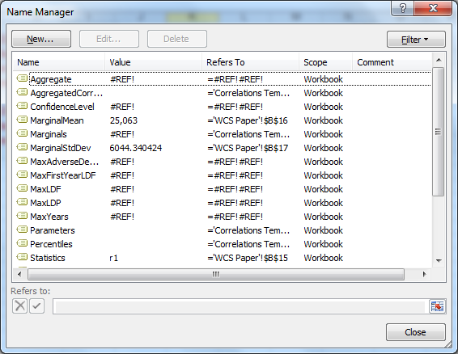

Appendix 1 Random Variable Generation in HPC Dynamo

Introduction
A hallmark of Dynamo is the ingenious methods originally used by designers to assure random number replication across different runs. Random number generators such as the Excel cellular RAND() function is volatile and produces a non-replicable sequence. Every time a workbook is calculated, the RAND() function returns a different uniformly distributed number. This has two important consequences: (a) debugging that may be related to numeric values is difficult or impossible because the numbers are not stationary across runs, and (b) results cannot be replicated either for auditing or comparisons that require a body of the computations to remain immutable while another is being used in an a sensitivity or similar ceteris parabus analysis. Reverse scenario analysis may require recasting a dynamic financial analysis to reflect the exact circumstances leading to an interesting financial result. The random variable values associated with that scenario must be replicable and identified with that scenario.
The original design both enabled replication and scenario lookup. The HPC version also does this too. Because simulations are parallelized across many instances of Excel running the workbook over a cluster, the problem of random variable generation was exacerbated with respect to run replication. Any simulation done on a compute node could be done on any compute node and, therefore, the capacity for replication must extend throughout the cluster. It also must be replicable for any given simulation at the client level too.

Appliances for Correlated Random Variable Generation
The random number generation methodologies also required modification for correlated random variables. The problem of replication for correlated variables imposes a new dimension. Consider two cells with random variables. If they are correlated, the distributions must be stationary during the entire simulation. Variates must be drawn in a multivariate fashion; so, during the i^{th} simulation cell A and cell B must jointly use data from the i^{th} n-tuple of the multivariate distribution. The marginal distributions must be stationary distributions. There is nothing inherent in Dynamo workbook design that assures stable parameters for an intrinsic function such as the inverse normal. Therefore, a first requirement is to ascertain that any given intrinsic function has stable parameters throughout the simulation.
The approach for determining parameter stationarity is to record parameter values observed during a representative number of iterations. This test is done every time the Pod Setup dialog is used. The reader may be wondering how the system knows a cell contains a random variable! The intrinsic functions of interest, say, NORMINV, are decorated. Decoration at this writing is done by prefixing the variable with a system-designated prefix. That prefix is CAP_ which was chosen because the HPC implementation using correlated variates was done using a DFATech Excel Add-in using the Iman-Conover non-parametric method based on Spearman rank correlation.
The decoration of random variables is done programmatically—there is a Dynamo utility menu item for variable decoration. Only some of the inverse functions are decorated: NORMINV, LOGINV and BETAINV. Further, all occurrences of them throughout the workbook are decorated. Programmers interested in extending the list are referred to procedure DecorateRVFormulas and the complementary procedure UndoDFATechRVDecoration .

Appendix 2 Programming Notes Relevant for HPC

This appendix describes various programming methods which are important to the operation of the model and necessitated by HPC usage.

Knowing When a Workbook is Operating on a Compute Node
The importance of knowing when operation is in a compute node relates to the fact that the same workbook typically is serving multiple functions:
- It is the interfacing mechanism seen by the user and operates as a graphics user interface (GUI). In this capacity it is presenting menus and enabling the user to flex various system features. This mode of operation is neither required nor used during compute node operation of the workbook in an HPC cluster.
- It is the vehicle for launching an HPC run either on a cluster or on the client machine in a standalone fashion. This is a special subset of the GUI action noted above.
- It may use add-ins that need to be accessible and opened regardless of whether the workbook is serving in a client capacity and standalone or working on a compute node where the add-in also is required for computations during HPC_Execute.
- There may be actions that must occur during closing of the workbook when it is operating on a compute node but which may not necessarily be desired when it is closed on a client workstations (e.g., the add-in is being worked and the user doesn’t want it closed just because the Dynamo workbook is closed.
These various purposes served by a workbook are a conundrum when they must be differentiated. The solution used in Dynamo involves the use of two booleans. One indicates that HPC_Execute has not occurred and the other indicates that the workbook has not been used in a GUI capacity. The GUI boolean is triggered by the use of a right-mouse click. Mouse action cannot occur when the workbook is being handled by a compute node! Similarly another boolean may be used to signal first time entry into HPC_Execute when certain computational setup actions are required and only required once (e.g., a computation add-in must be made available to the workbook). These booleans are bHasHPCExecuted and bHasRightClicked. They are reset during workbook open or reset events.

Appendix 3 System Procedures

Introduction
This appendix identifies many of the VBA procedures used in HPC Dynamo. It is presented in tabular form and likely will be of interest only to programmers. Other sections of the Appendix expand on some of the procedures when their complexity or interrelatedness warrants.

Table 3 Modules in Dynamo VBA Code
Module | Contents and Function

Appendix 4 Developer’s Notepad

Introduction
This appendix contains various developers’ comments regarding VBA code or other related systems operations in Dynamo. These notes may be cryptic—they may be of value only to systems designers and VBA coders using Dynamo. They are presented in no particular order.

Cluster Starvation
The HPC cluster operation involves HPC_Execute operations that may or may not be fast, but because there are many compute nodes, in the collective they likely are fast. The result is that there will be frequent callbacks to the cllient’s HPC_Merge code. Similarly HPC operation will be making rapid callbacks to HPC_Partition operating on the client too. If the HPC callbacks are not handle by the client fast enough, a condition known as cluster starvation occurs. The result is that job performance degrades and in an extreme may fail to process the final portion of the job—the job remains in limbo and must be canceled using Cluster Manager or from the client using a Dispose method on the Microsoft_HPC_Excel IExcelClient object.
The manifestation of starvation really is in the inability to process events at HPC_Merge (or HPC_Partition) fast enough. When there the simulation count is high and there is a core resource allocation in HPC, almost anything that is done in HPC_Merge is too slow—starvation and an HPC job hang are likely outcomes. In Dynamo, this is regulated by the Drain Interval. This setting in worksheet Simulation Data should be raised if you encounter an out-of-memory Excel dialog or log error during a simulation. The only reason for a low drain interval (say, <=100) would be to see results as they are produced. A larger drain interval of 1,000 (recommended) will result in merge events being stashed in memory with a drain occurring every 1,000 events. One will not see results emerge except every 1,000 events with such a setting.

Interaction between Dynamo and DFATech Pod Workbook.xlsm
Both workbooks operate in the same instance of Excel. Were the pod workbook to be opened first, there is no menu-driven option for opening Dynamo. However, Dynamo can sense the presence of an already opened pod workbook. A requirement is that both workbooks be present in the same directory.
Dynamo will determine the presence of the pod workbook by using a scan of Application.Workbooks. In general, the creation of the pod workbook object reference is done through selection within the pod workbook listbox in Pod Setup. That is, the operative pod workbook must be identified through a mapping of it using this dialog. Once the selected workbook is successfully mapped, it become the operative, associated pod workbook. Cells in the system and pod map worksheets are loaded with the workbook name. Once this is done, the pod workbook can be opened by an instance of Excel running anywhere in the HPC cluster provided this operative pod workbook is on the HPC file share. So, when multivariate correlation is used, the full Dynamo HPC package must contain both workbooks.
When the HPC job session is opened in HPCControlMacros. CalculateWorkbook, the associated pod workbook and dynamo workbooks are saved as a copy to the file share.
Methods within the pod workbook are run in the Pod using a Workbook.<method name> call. The pod workbook object has VBA code such as Public Sub SimulateMarginal and Public Sub CorrelateMarginals. This is code appearing in ThisWorkbook object in the pod workbook. From Dynamo, the calling of this methods is done using statements such as
wbP.CorrelateMarginals ws, nEr

Appendix 5 Links to Help Resources and Video Clips

Introduction
HERE!!! This is done differently. This section needs to be rewritten!!!
The help materials should be organized as a web site, but that chore remains for another day. This appendix anticipates that all of the documents, clips and another material for which links have been created are in the same folder as this document. The following listings are not really links. Rather, they work similar to a link using a macro in this workbook.

Steps for activating a “Link”
- The tables of help items contain three columns. The first contains the name of the help item, the second is the filename associated with the item, and the third column contains a brief description. Please select the entire file name (column 2).

Links to Documents
Item | Filename (Select Here) | Description
Variable Correlation | Pod XLA.docx | A group of variables may be designated as a correlated pod. This XLA is used in connection with a Dynamo workbook to specify the subset of DFA variables that are correlated. Certain conditions must be met, an you will need to run

Links to Video Clips
Item | Filename (Select Here) | Description

End Notes

William C. Scheel, Ph.D., DFA Technologies, LLC
It may be that the user doesn’t always care about aligning a result with a particular bit of information on which it was dependent. But, we do. In Dynamo, the whole process must be replicable. We need to be able to repeat simulation 1 at a future point in time. Among other reasons, this is a requirement for reverse scenario analysis—a requirement under Solvency II.
Technically, the workbook on a compute node may be different than the workbook on the client computer launching the HPC job.
The in-bound variant argument is not likely to be the same as the variant that is constructed for the HPC_Execute return.
The 64K limitation was effective as of this writing. The author finds this limitation unnecessarily restrictive in some circumstances; Microsoft was considering eliminating it.
The statistics table can be recalculated using a right-click menu button.
These cluster computers having access to are not Azure compute nodes that may also be deployed. The cluster file share is not seen by Azure unless one is using Azure Windows Connect. HPC Dynamo has been designed and tested using a local HPC cluster that is augmented by Azure compute nodes, but not using Windows Azure Connect. The latter is a more seamless usage of Azure nodes because a local head node then can be seen by the Azure nodes and a global file share for the entire cluster becomes possible. Instead, Dynamo has code that will manage the Azure nodes using low-level system utilities for uploaded workbook packages. But, in this case, a copy of workbooks is place in Azure storage rather than having Azure work through Connect to access workbook files.
There can be many head nodes, broker nodes and compute nodes. The head node computer name for cluster operation of Dynamo is required.
Please note that the capital letters “O” and “I”. These are not numbers.
The technique is to use the string encompassing the left reference separated by the character, “:”. For example, “I:” would find formulas containing a right worksheet whose name ends with the character “I”.
More precisely, there are two “end-points” within the 3D expression. The name of a worksheet can be renamed by clicking on a worksheet in the bottom name bar, doing a right-click and selecting “Rename.” Therefore, it is essential that the existing worksheets that are endpoints within the contiguous range be kept in that position. New worksheets may be inserted in between. Endpoints may be freely renamed, but they must still remain the endpoint wrappers for all similar worksheets in between. Otherwise, the 3D formulas will be compromised.
Because Dynamo is a macro workbook with the extension .xlsm, there also is a change in file size associated with VBA program code modifications.
Please see Appendix ???? for a discussion of this capability. It enables an existing Dynamo workbook to be integrated with the new features found in HPC Dynamo.
The number is a system variable in the Simulations Data worksheet.
John Burkett, Jennifer Cheslawski, Gerald Kirschner, Timothy J. Pratt and Diana Rangelova, “Holisstic Approach to Setting Risk Limits: ERM for the Masses,” Casual Actuarial Society E-Forum, Winter 2010.

